**Kallam Haranadhareddy Institute Of Technology**

**A CRM Application for Cosmetics Store Management**

**By**

**N N V C H Sai Sasank**

[218x1a42d2@khitguntur.ac.in](mailto:218x1a42b1@khitguntur.ac.in)

**Shaik Rafi**

[228x5a4210@khitguntur.ac.in](mailto:218x1a4271@khitguntur.ac.in)

**A Tarun Kumar**

[218x1a42a0@khitguntur.ac.in](mailto:228x5a4209@khitguntur.ac.in)

**Shaik Riyaz**

[218x1a4292@khitguntur.ac.in](mailto:218x1a42b8@khitguntur.ac.in)

**Project Overview**

The Cosmetics Store CRM is a **comprehensive digital solution** designed to revolutionize retail management for beauty businesses. By **integrating advanced customer profiling**, **real-time inventory tracking**, and **personalized marketing capabilities**, the application aims to **enhance customer experiences** and **streamline operational efficiency**. The system will leverage modern technologies to provide seamless management of **customer interactions**, **product stocks**, **sales analytics**, and **targeted promotional strategies**. **Key features** include **detailed customer profiles**, **automated inventory alerts**, **sales performance dashboards**, and an **integrated loyalty program management**. The project targets **medium to large cosmetics retailers** seeking to transform their customer relationship and inventory management through a **robust, user-friendly technological platform**.

**INTRODUCTION**

The Cosmetics Store Management solution in Salesforce is engineered to enhance operational efficiency, elevate customer engagement, and support business growth by leveraging the comprehensive tools and features of the Salesforce platform.

**Objectives:**

**1. Customer Relationship Optimization**

The CRM aims to develop a comprehensive understanding of customer interactions in the cosmetics retail environment, creating detailed profiles that capture individual beauty preferences, purchasing behaviors, and personalized engagement strategies to foster long-term customer loyalty.

**2. Inventory Management Enhancement**

Implementing a sophisticated system to manage cosmetic product inventory challenges, the objective is to provide real-time tracking, precise stock management, and intelligent insights into product performance, ensuring optimal inventory levels and minimizing wastage of time-sensitive beauty products.

**3. Personalized Marketing and Sales Strategies**

The CRM will leverage advanced data analytics to generate targeted marketing campaigns, create personalized product recommendations, and develop loyalty programs that resonate with individual customer needs, ultimately driving sales and enhancing customer satisfaction in the competitive cosmetics market.

## **4. Operational Efficiency Improvement**

## By streamlining business processes and providing real-time performance insights, the CRM seeks to reduce manual administrative tasks, support data-driven decision-making, and create a more agile and responsive management approach for cosmetics store operations.

## **5. Customer Experience Enhancement**

The system will create a holistic approach to customer interaction, supporting personalized beauty consultations, tracking service interactions, and enabling seamless omnichannel experiences that build meaningful connections between customers and the cosmetic brand.

## **6. Sales Performance Optimization**

Developing comprehensive tools to track sales performance, analyze product trends, and support strategic decision-making, the CRM will help identify growth opportunities, optimize sales strategies, and maximize revenue potential in the dynamic cosmetics retail environment.

## **7. Compliance and Data Management**

Ensuring robust management of customer data privacy, product information accuracy, and regulatory compliance, the CRM will provide a secure and reliable platform for handling sensitive information while maintaining the highest standards of data protection and integrity.

# **Methodology:**

## **Discovery:** Conducted comprehensive interviews with cosmetics store managers, sales representatives, and customers to identify specific CRM needs and operational challenges.

## **Design:** Designed a comprehensive CRM solution tailored to cosmetics retail, focusing on customer profiling, inventory management, and sales tracking functionalities.

## **Development:** Developed and tested the CRM system using modern technologies, integrating features like customer database, sales analytics, and marketing automation tools.

## **Deployment:** Rolled out the final CRM solution across target cosmetics retail stores, providing training and support for seamless adoption.

**Key Salesforce features and concepts applied in the project:**

* **Custom Object and Fields:** Created objects for Customers, Consultants, Retailers, and Others, as well as custom fields to store relevant information.
* **Tabs:** Configured tabs for quick access to objects like Customers, Consultants, Retailers, and Others.
* **Page Layout:** Customized the page layout for the Consultant object to display relevant fields and sections.
* **Lightning App:** Created a lightning app in the salesforce org for a streamlined experience and easy navigation.
* **Profiles:** Created profiles for controlling the actions of users in the org.
* **Setup Roles:** Assigned roles for the user to control what a user can see.
* **Users:** Created users for necessary functioning of org.
* **Records:** Created records in the lightning app for data analysis.
* **Reports:** Developed informative reports for the tracking of inventory, consultants, customer information, and so on.
* **Dashboards:** Created dashboards for the better understanding of the market and analysis of past data.

**Project Design and Implementation**

**1. Creation of Salesforce Org:**

Creating a developer org in salesforce.

* Go to [developers.salesforce.com/signup](https://developer.salesforce.com/signup).
* Click on sign up.
* On the sign-up form, enter the following details:
* First name & Last name
* Email
* Role: Developer
* Company: College Name
* County: India
* Postal Code: pin code
* Username: should be a combination of your name and company.

This need not be an actual email Id, you can give anything in the format: username@organization.com

Click on sign up after filling these.

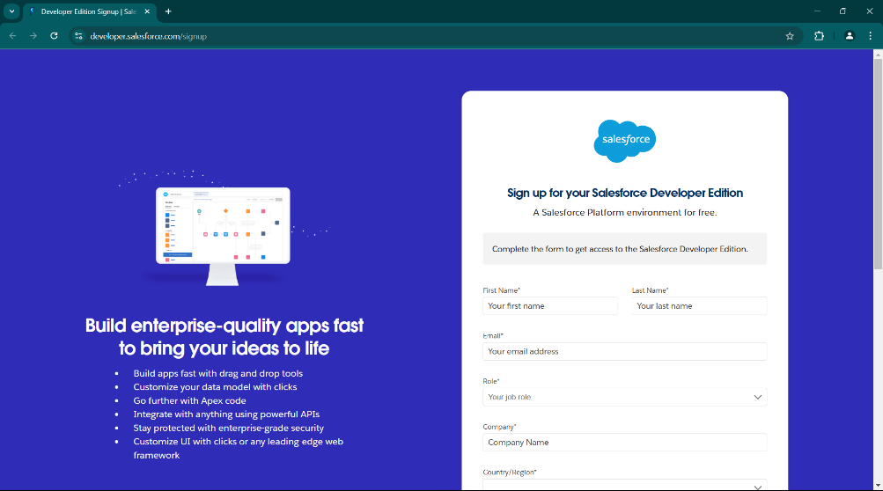

Account Activation

Go to the inbox of the email that you used while signing up. Click on the verify account to activate your account. The email may take 5-10mins

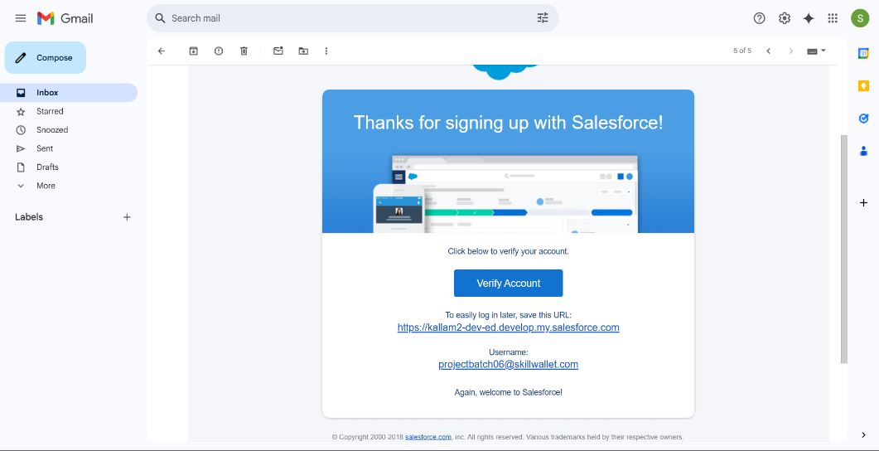

Login To Your Salesforce Account

* Go to salesforce.com and click on login.
* Enter the username and password that you just created.
* After login, you will see the home page.

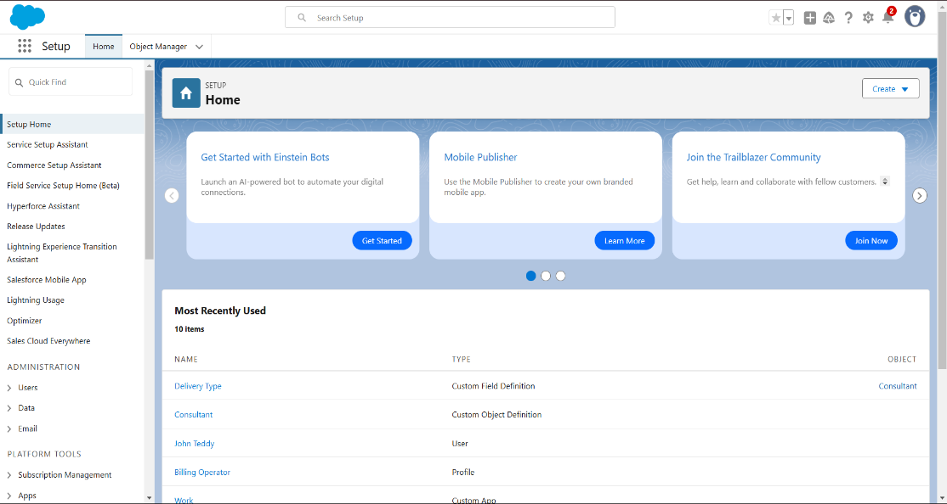

**2. Creation of Objects:**

**I. Creation of Our Customers Object:**

Creation of Objects for Urban Color For this Urban Color, we need to create 3 objects i.e., Our Customers, Consultants, Retailers, and others.

The below steps will assist you in creating those objects.

* Click on the gear icon and then select Setup.
* Click on the object manager tab just beside the home tab.
* After the above steps, have a look on the extreme right; you will find a Create Dropdown Click on that and select Custom Object.
* Creation of Our Customer Object

On the Custom Object Definition page, create the object as follows:

* Label: Our Customer
* Plural Label: Our Customers
* Record Name: Our Customer
* Check the Allow Reports checkbox
* Check the Allow Search checkbox
* Click Save.
* Now create a custom tab. Click the Home tab, enter Tabs in Quick Find, and select Tabs.
* Under Custom Object Tabs, click New.
* For Object, select Our Customer.
* For Tab Style, select any icon.
* Leave all defaults as is. Click Next, Next, and Save.

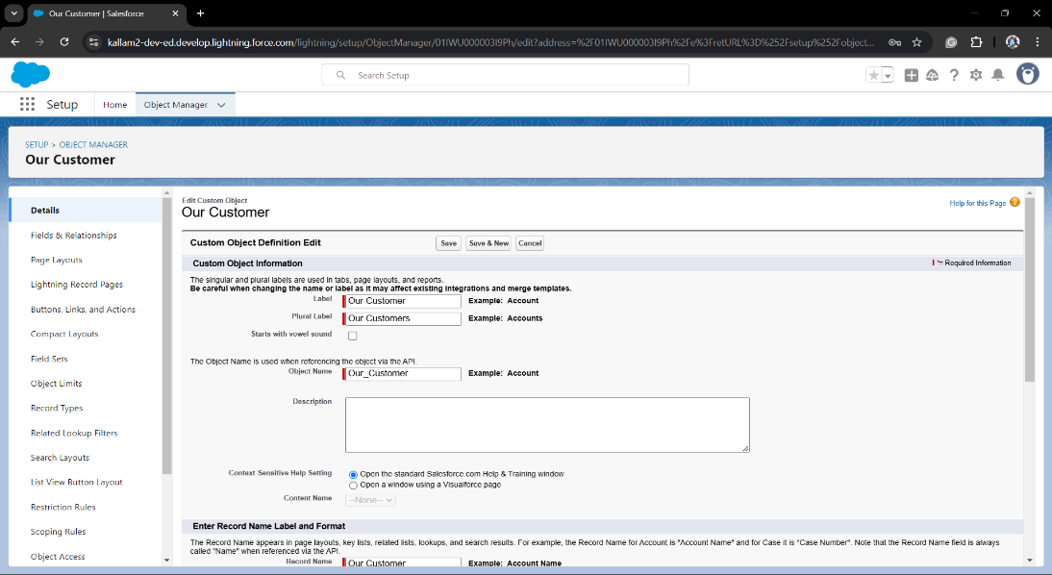

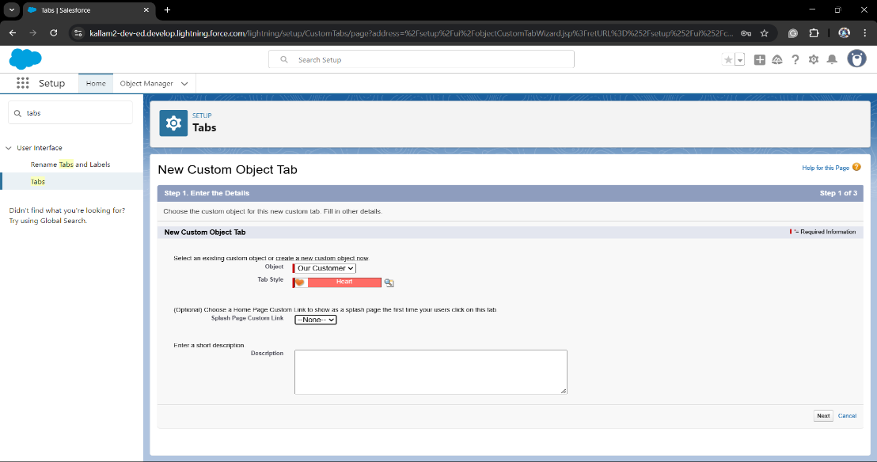

**II. Creation of Consultant Object:**

The below steps will assist you in creating those objects.

* Click on the gear icon and then select Setup.
* Click on the object manager tab just beside the home tab.
* After the above steps, have a look on the extreme right you will find a Create Dropdown click on that and select Custom Object.
* Creation of Consultant Object

On the Custom Object Definition page, create the object as follows:

* Label: Consultant
* Plural Label: Consultants
* Record Name: Consultants
* Check the Allow Reports checkbox
* Check the Allow Search checkbox
* Click Save.
* Now create a custom tab. Click the Home tab, enter Tabs in Quick Find and select Tabs.
* Under Custom Object Tabs, click New.
* For Object, select Consultants.
* For Tab Style, select any icon.
* Leave all defaults as is. Click Next, Next, and Save.

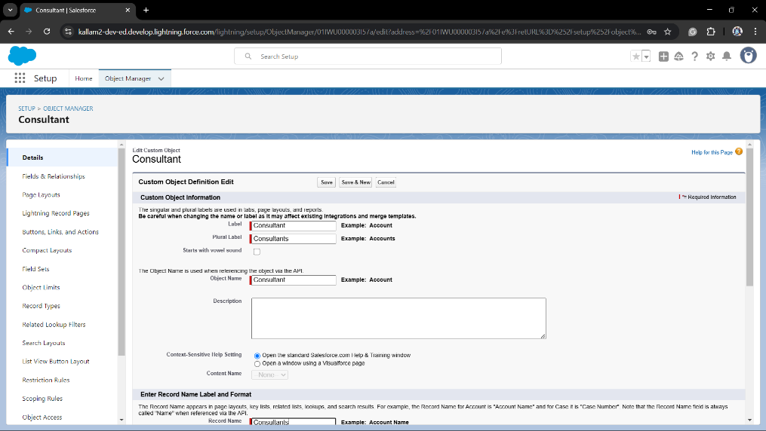

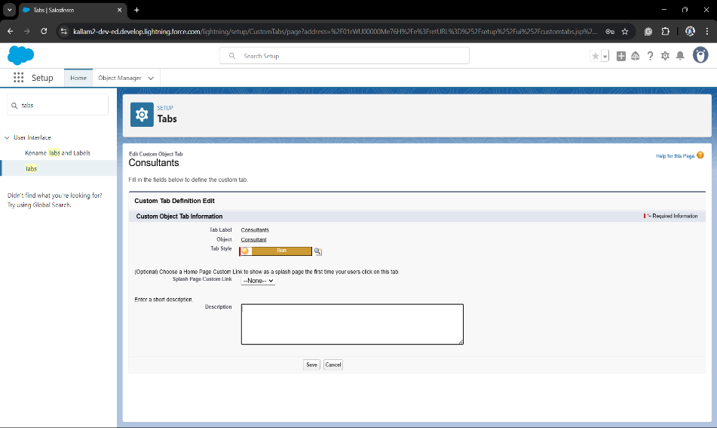

**III. Creation of Retailers Object:**

The below steps will assist you in creating those objects.

* Click on the gear icon and then select Setup.
* Click on the object manager tab just beside the home tab.
* After the above steps, have a look on the extreme right you will find a Create Dropdown click on that and select Custom Object.
* Creation of Retailer Object

On the Custom Object Definition page, create the object as follows:

* Label: Retailer
* Plural Label: Retailers
* Record Name: Retailers
* Check the Allow Reports checkbox
* Check the Allow Search checkbox
* Click Save.
* Now create a custom tab. Click the Home tab, enter Tabs in Quick Find and select Tabs.
* Under Custom Object Tabs, click New.
* For Object, select Retailers.
* For Tab Style, select any icon.
* Leave all defaults as is. Click Next, Next, and Save.

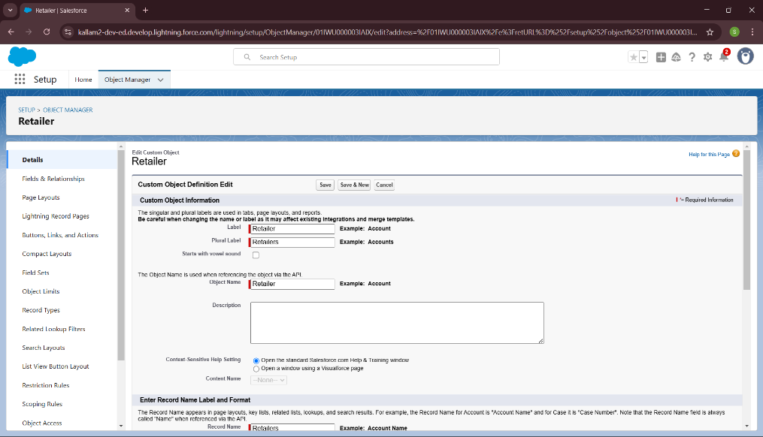

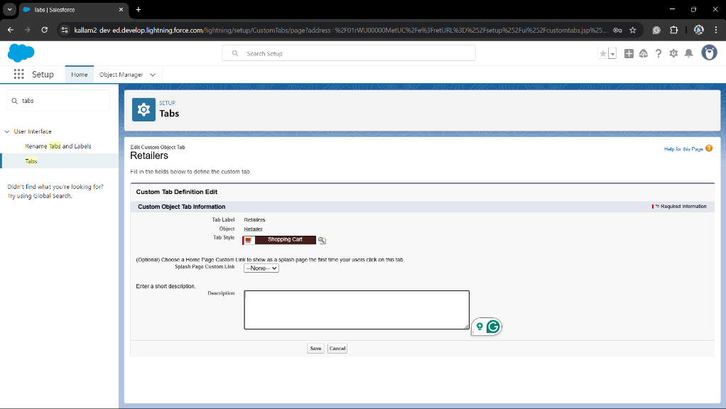

**IV. Creation of Others Object:**

The below steps will assist you in creating those objects.

* Click on the gear icon and then select Setup.
* Click on the object manager tab just beside the home tab.
* After the above steps, have a look on the extreme right you will find a Create Dropdown click on that and select Custom Object.
* Creation of others Object

On the Custom Object Definition page, create the object as follows:

* Label: other
* Plural Label: others
* Record Name: others
* Check the Allow Reports checkbox
* Check the Allow Search checkbox
* Click Save.
* Now create a custom tab. Click the Home tab, enter Tabs in Quick Find and select Tabs.
* Under Custom Object Tabs, click New.
* For Object, select others.
* For Tab Style, select any icon.
* Leave all defaults as is. Click Next, Next, and Save.

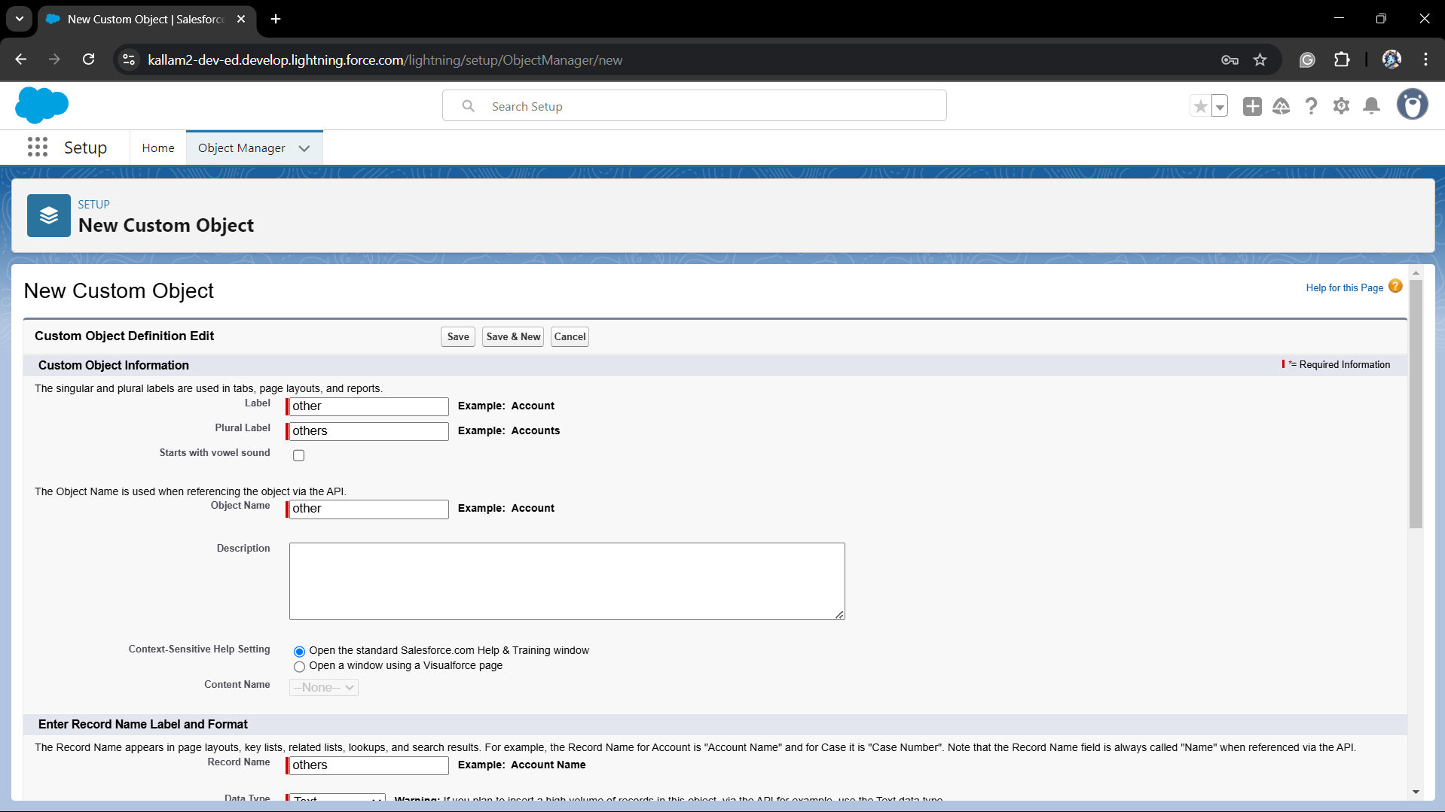

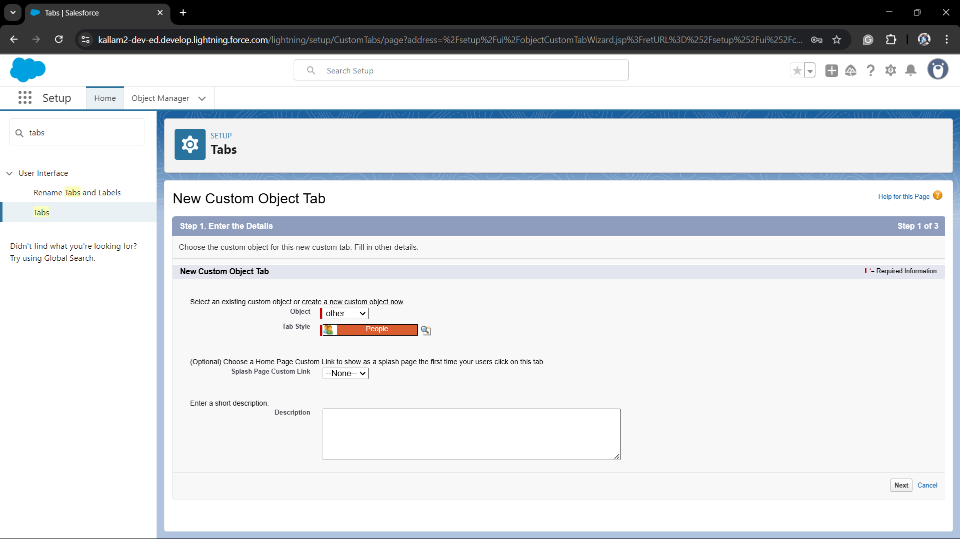

**3. Creation of Fields and Relationships:**

**I. Fields in Our Customers objects:**

Fields in Our Customers objects follow below data types:

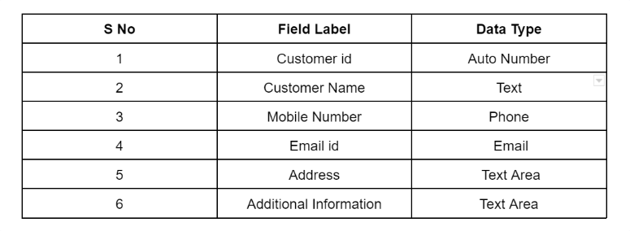

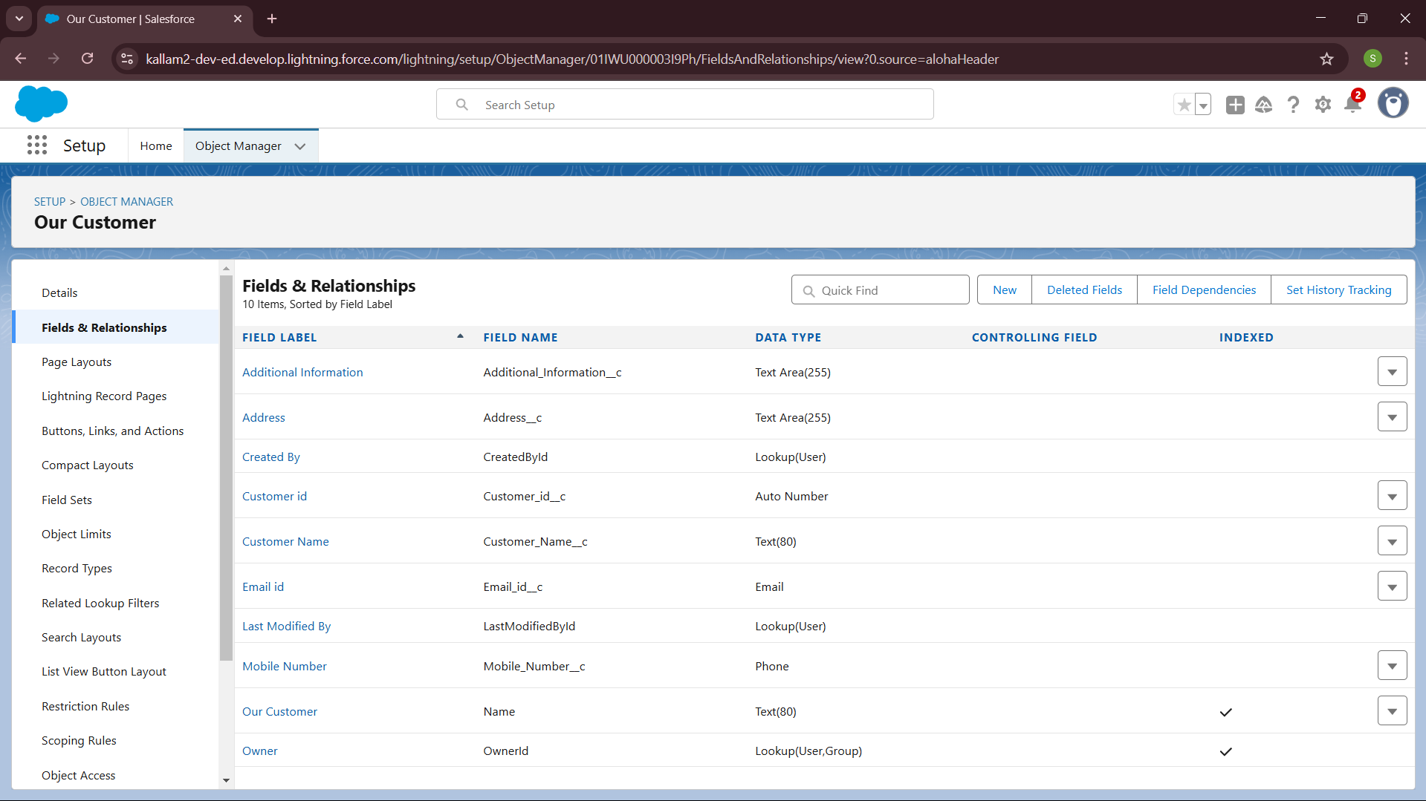

**II. Fields in Consultants objects:**

Fields in Consultants objects follow below data types:

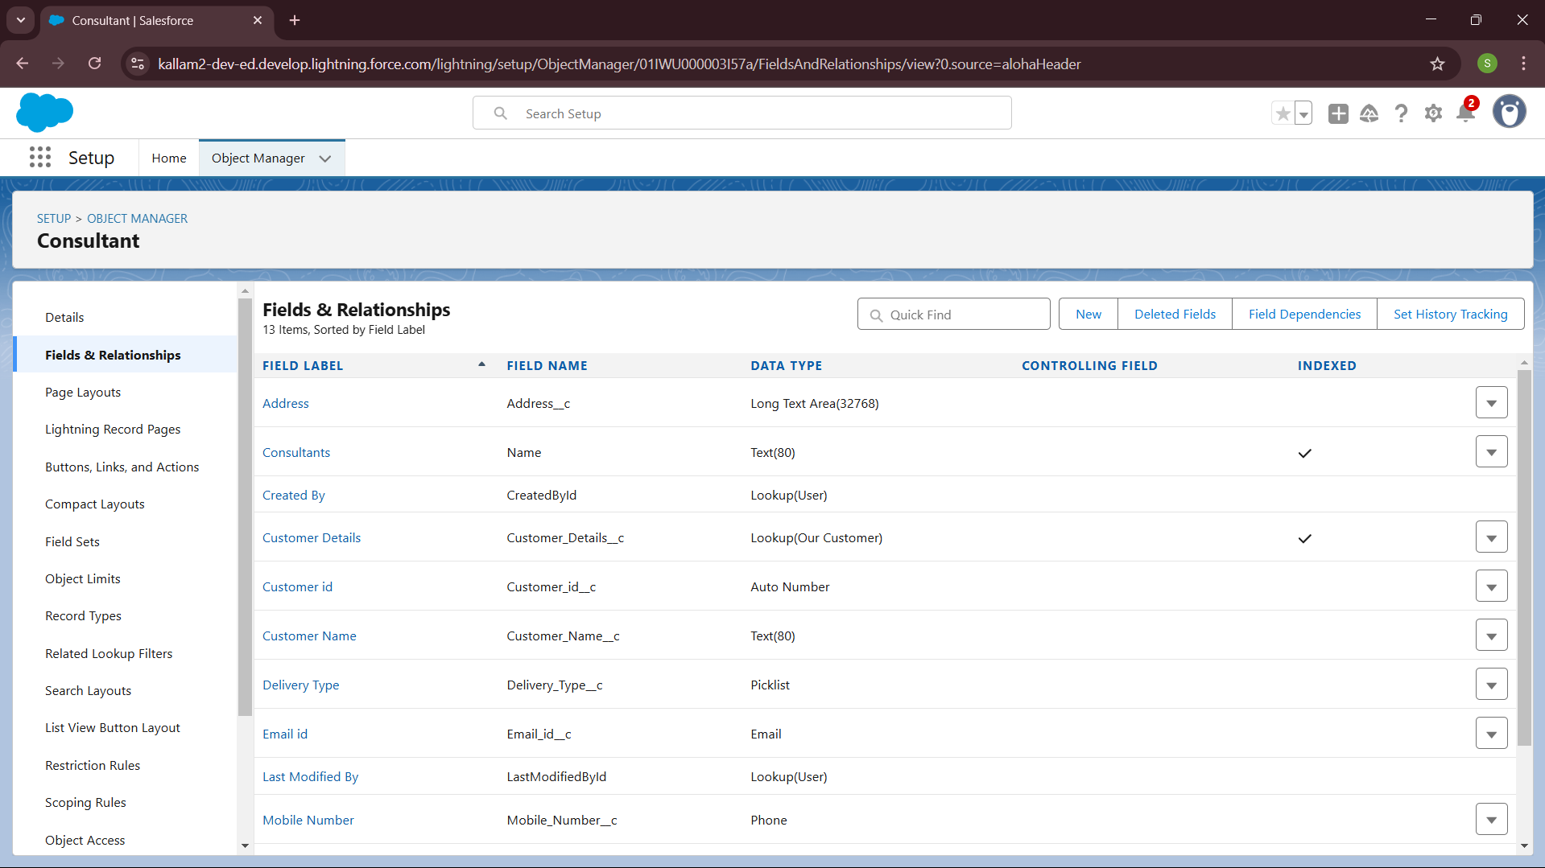 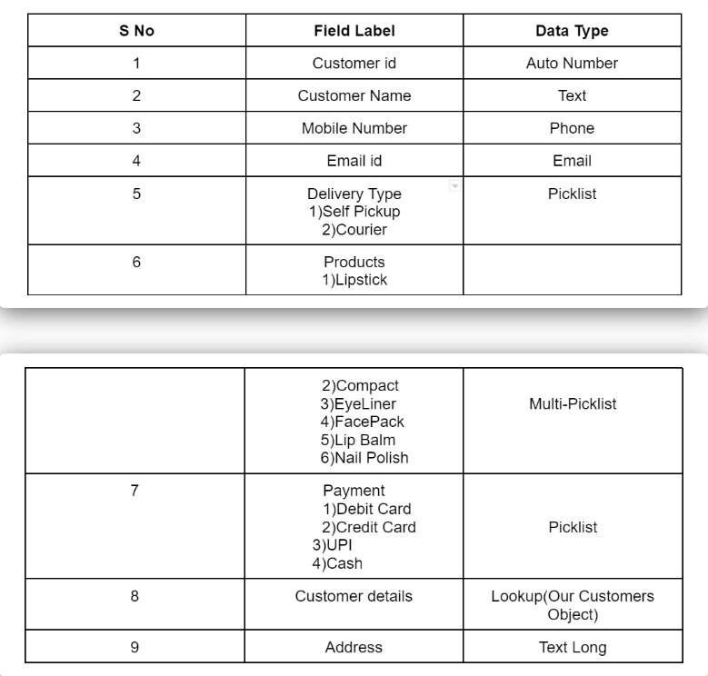

**III. Fields in Retailers objects:**

Fields in Retailers objects follow below data types:

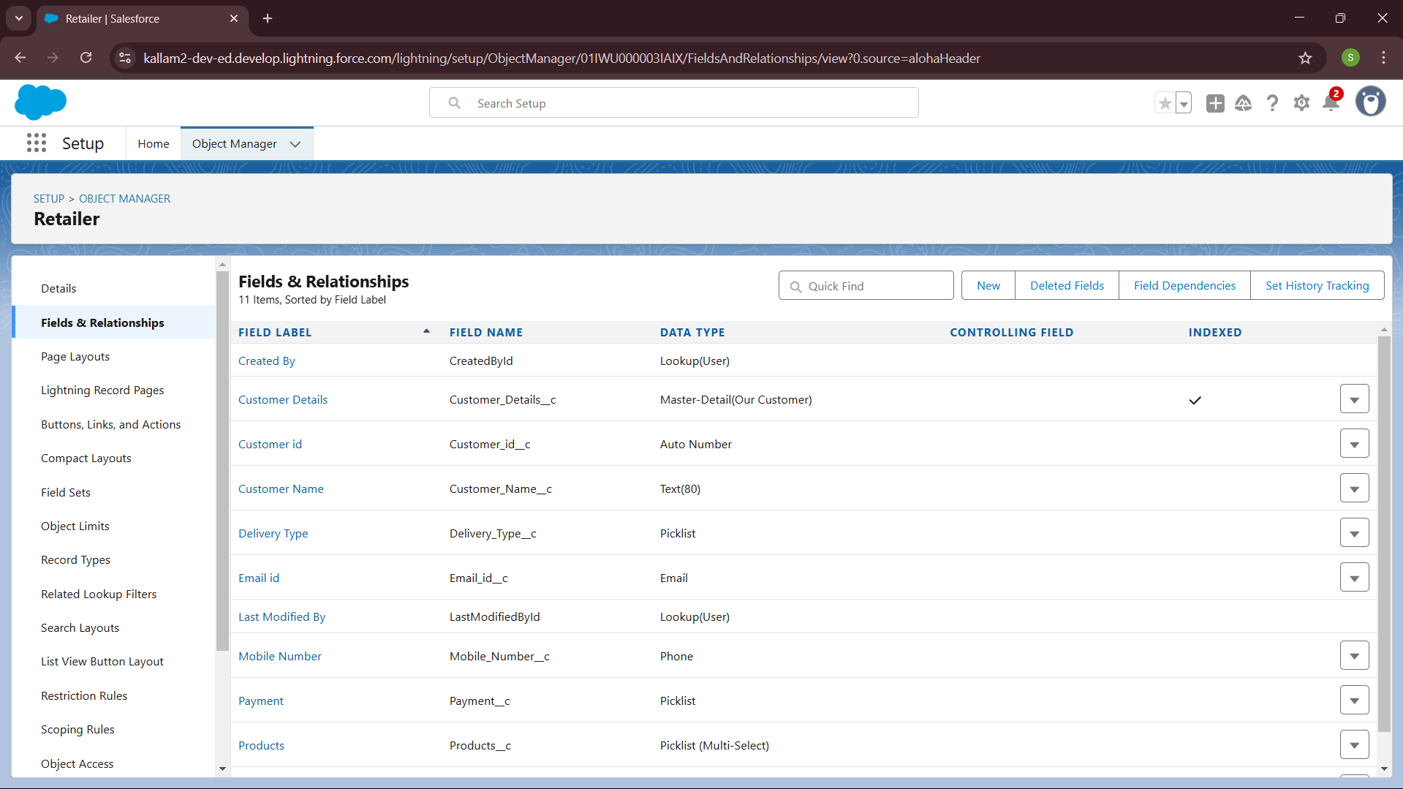

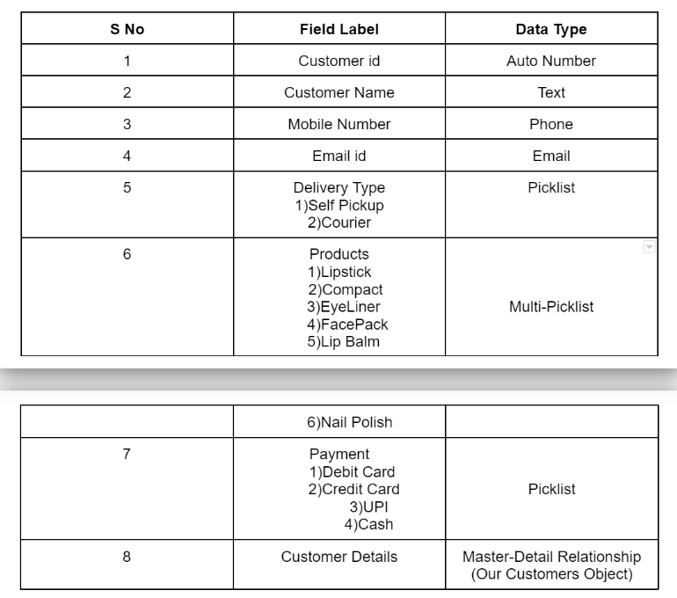

**IV. Fields in Others objects:**

Fields in Others objects follow below data types:

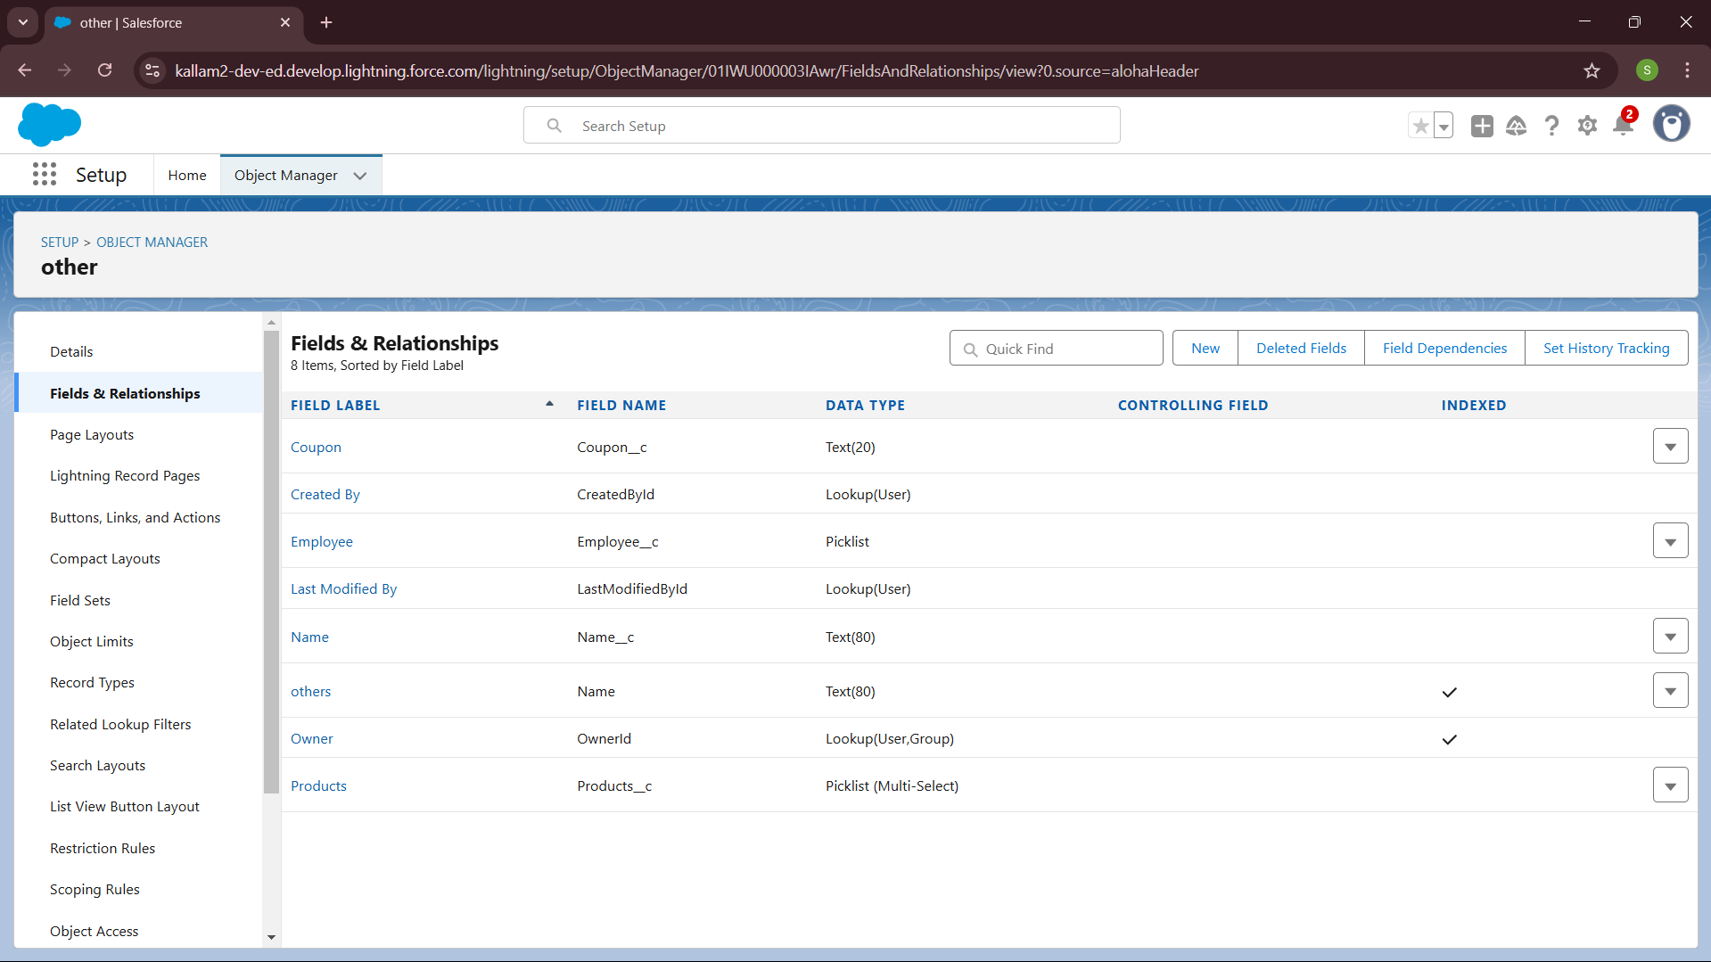

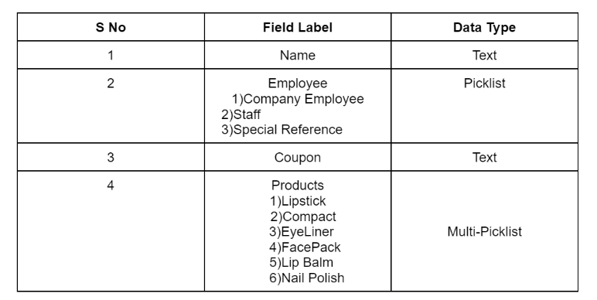

**4. Creation of Page Layouts:**

* From the Salesforce setup menu, go to "Object Manager" and select the Consultants object.
* Click on "Page Layouts" in the left sidebar. This will display a list of available page layouts for the selected object.
* Select the Consultant Layout page layout.

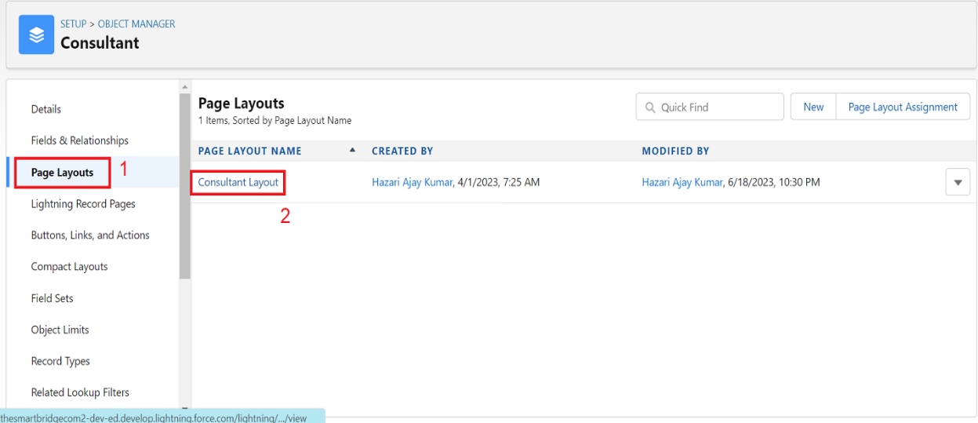

* 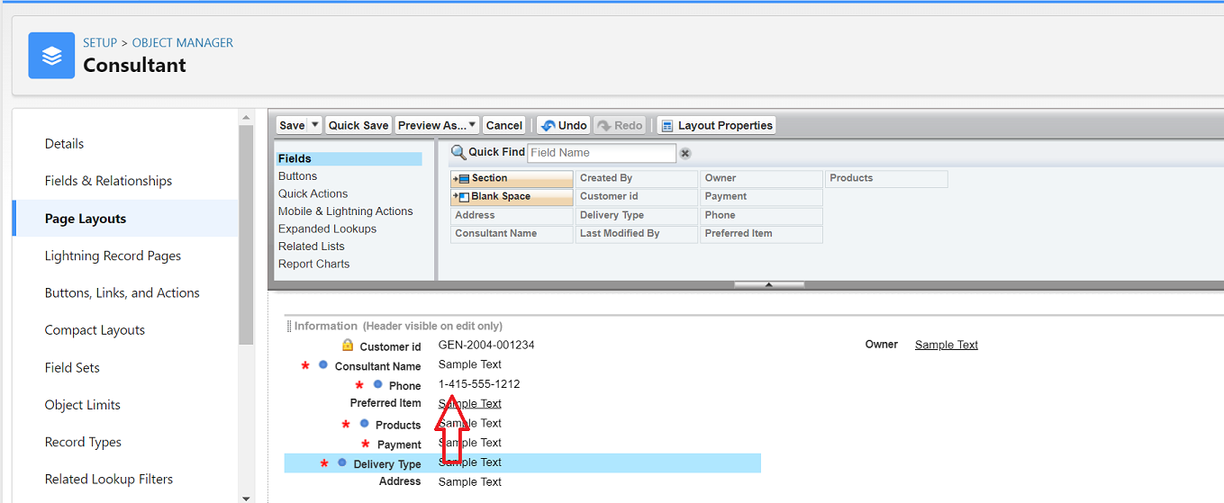 Click And Drag Delivery type and Address Fields Below Phone field.
* Click on Save.

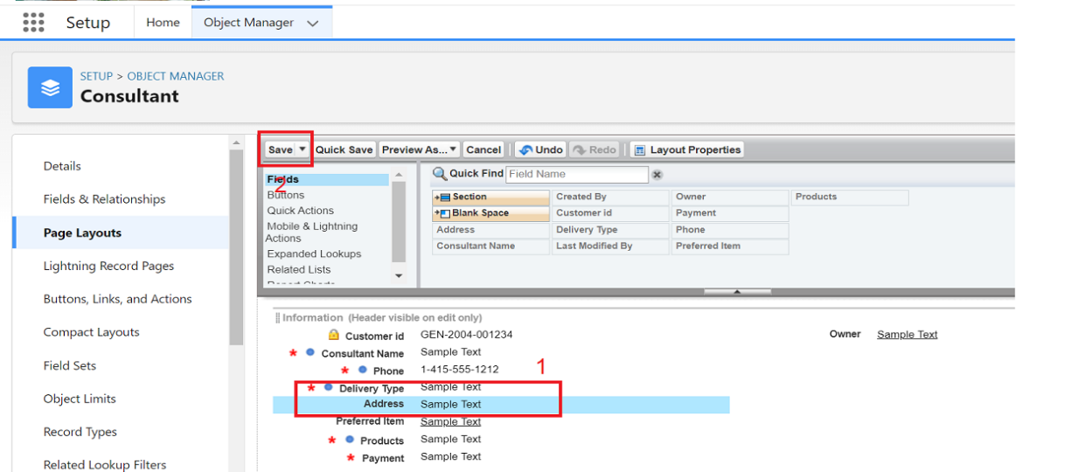

**5. The Lightning App Creation:**

To create a lightning app page:

* Go to setup page --> search “app manager” in quick find --> select “app manager” --> click on New lightning App.

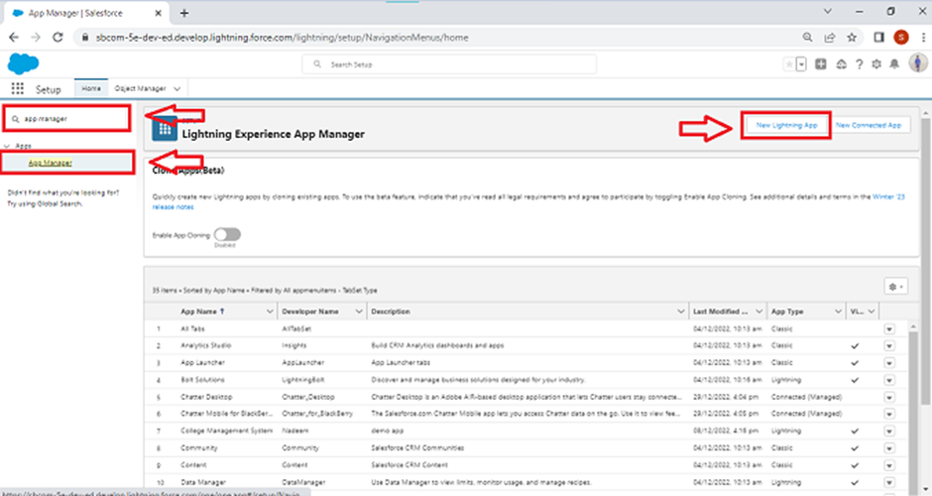

* 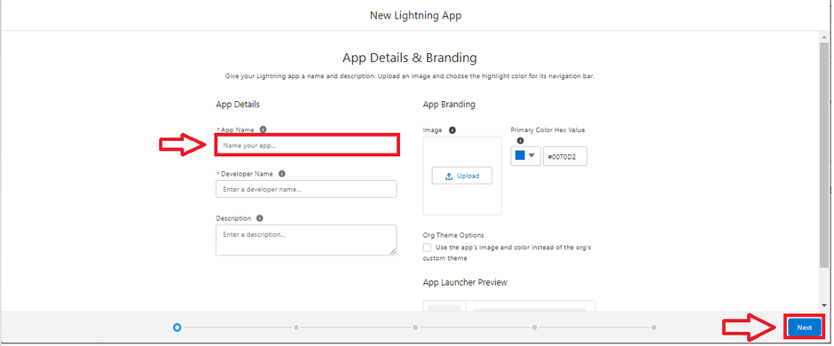Fill the app name as Urban Color in app details and branding --> Next --> (App option page) keep it as default --> Next --> (Utility Items) keep it as default --> Next.
* 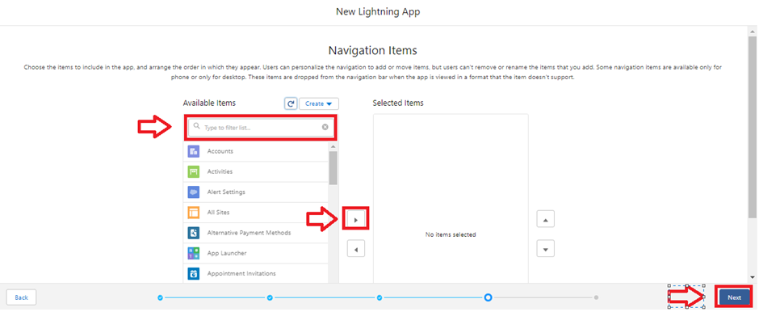To Add Navigation Items:
* 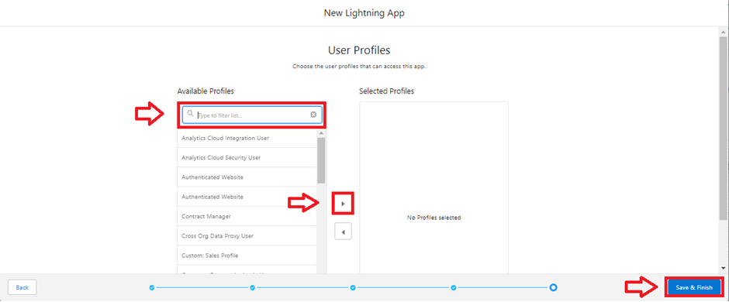Select the items (Our Customers, Consultants, Retailers, Others, Reports, Dashboards) from the search bar and move it using the arrow button --> Next.
* To Add User Profiles:
* Search profiles (System

administrator) in the search

bar --> save & finish.

**6. Creation of Profiles:**

Creating a Profiles: Now create a Store Supervisor profile and set its object permissions.

Creating a Profiles:

Now create a Store Supervisor profile and set its object permissions.

* From Setup enter Profiles in the Quick Find box, and select Profiles.
* From the list of profiles, find Standard User.
* Click Clone.
* For Profile Name, enter Store Supervisor.
* Click Save.
* While still on the Store Supervisor profile page, then click Edit.
* Scroll down to Custom Object Permissions and give access for Create, Read, Edit, Delete, View all and modify all for Our Customers, Consultants, Retailers, Others.
* Scroll down to Custom App Settings and give access for Urban Color.

To create a new profile:

* 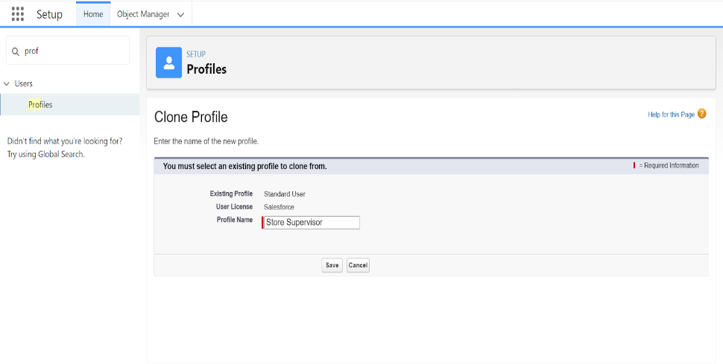Go to setup --> type profiles in quick find box --> click on profiles --> clone the desired profile (standard user is preferable) --> enter profile name --> save.
* 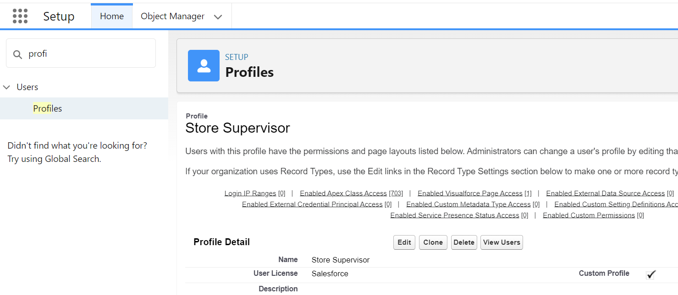While still on the profile page, then click Edit.

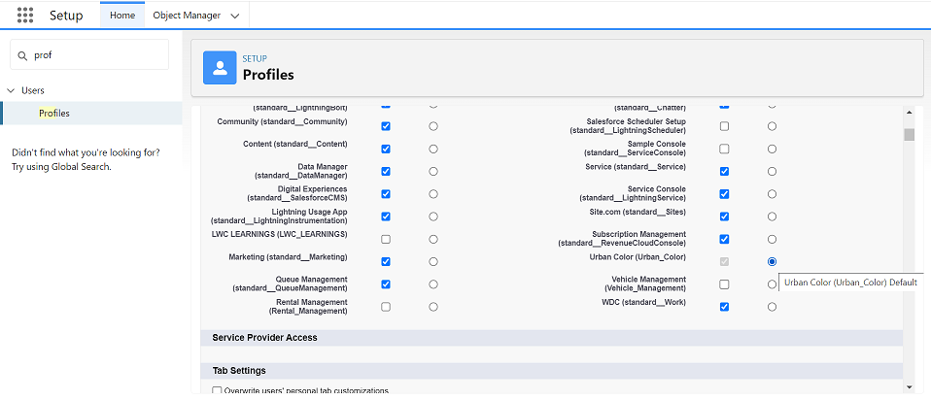

* Scroll down to the Custom object permission and give all access to the Consultants, Others, Our Customers, Retailers object.

* Click on Save.
* 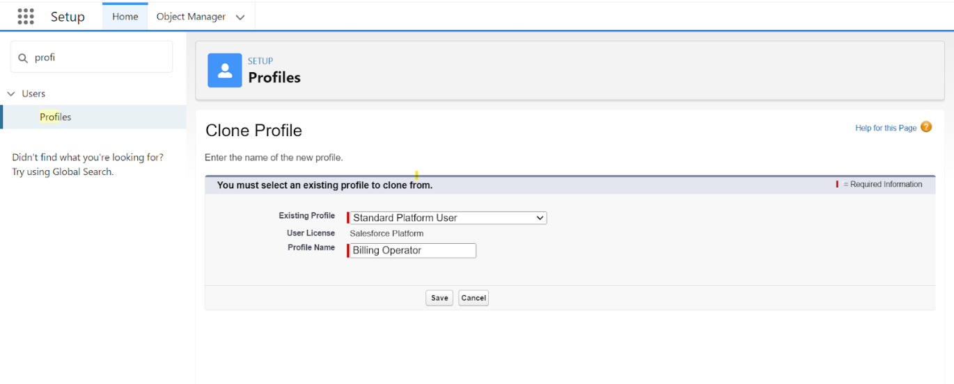Similarly Create operator profile, Clone Salesforce Platform user and give access only for Billing Operator.

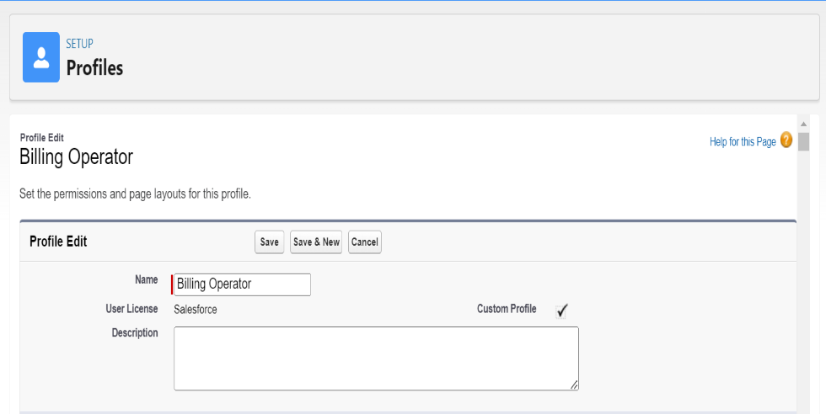

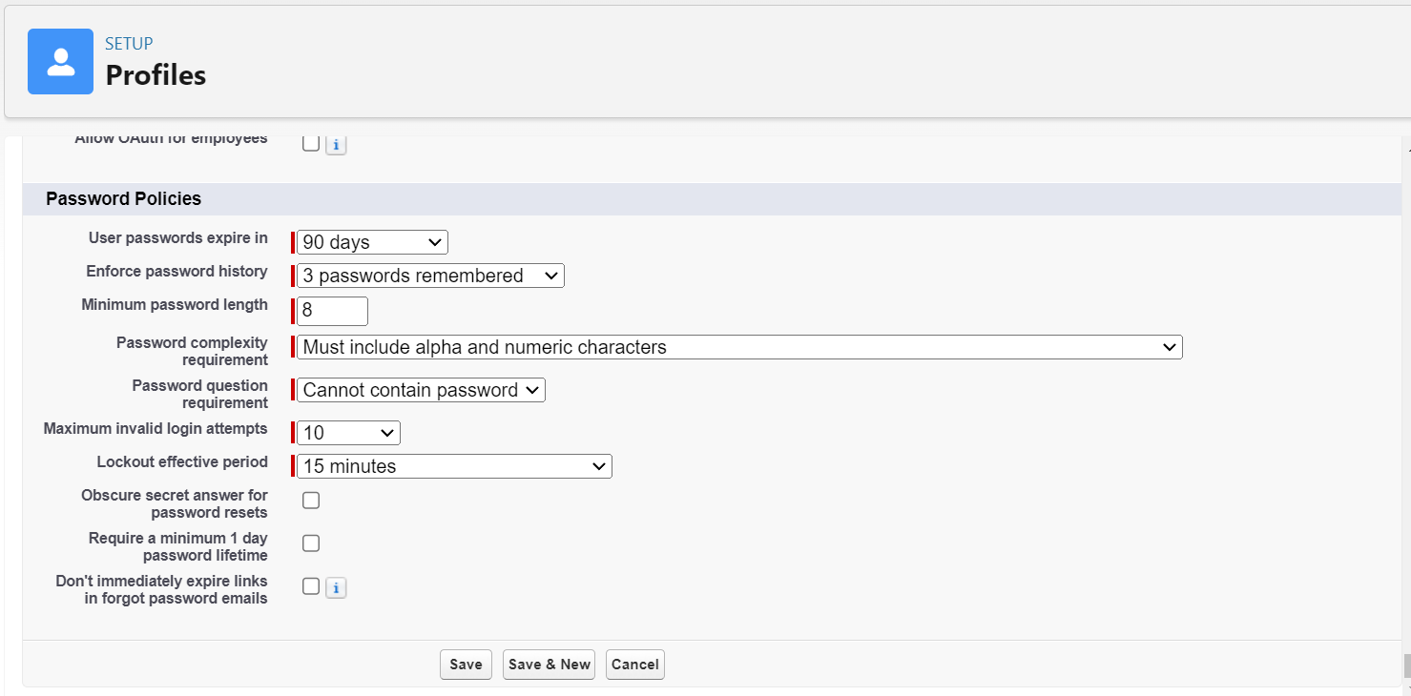

* Click On Save.

**7. Creating Roles:**

* Click on the Gear Icon
* Click "Setup"
* In the Quick Find box, enter "Roles"
* Click "Roles"
* Click on "Set Up Roles"
* Click "Expand All"
* Under the CEO, click on "Add Role"
* Fill up the Label as Store Head, Role Name Store_Head.
* Enter a Role name that will be displayed on Reports
* 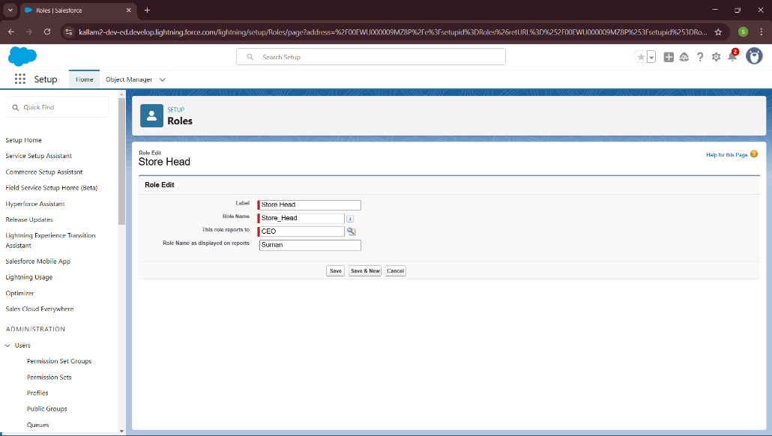Click on Save.

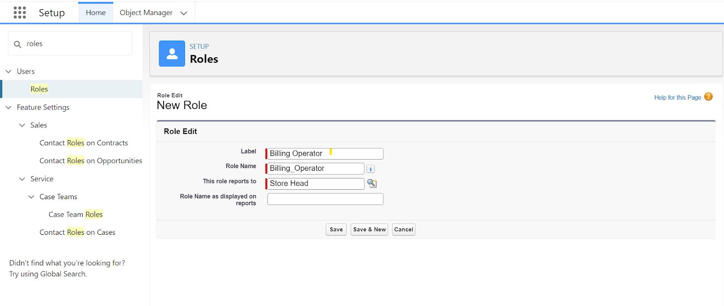

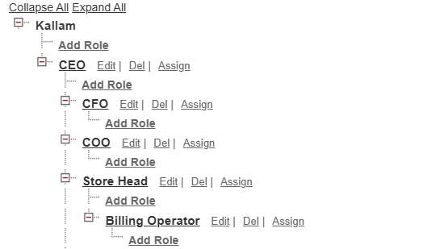

**8. User Creation:**

**I. First user:**

From Setup, in the Quick Find box, enter Users, and then select Users.

* Click New User.
* Enter the user’s name Amar K and (Your) email address and a unique username in the form of an email address. By default, the username is the same as the email address.
* Select a Role(Store Head)
* Select a User Licence As Salesforce.
* Select a profile as Store Supervisor.
* Check Generate new password and notify the user immediately to have the user’s login name and a temporary password emailed to your email.

Fill in the fields (first name, last name, alias, email id, username, nick name, role, user licence, profiles) --> save.

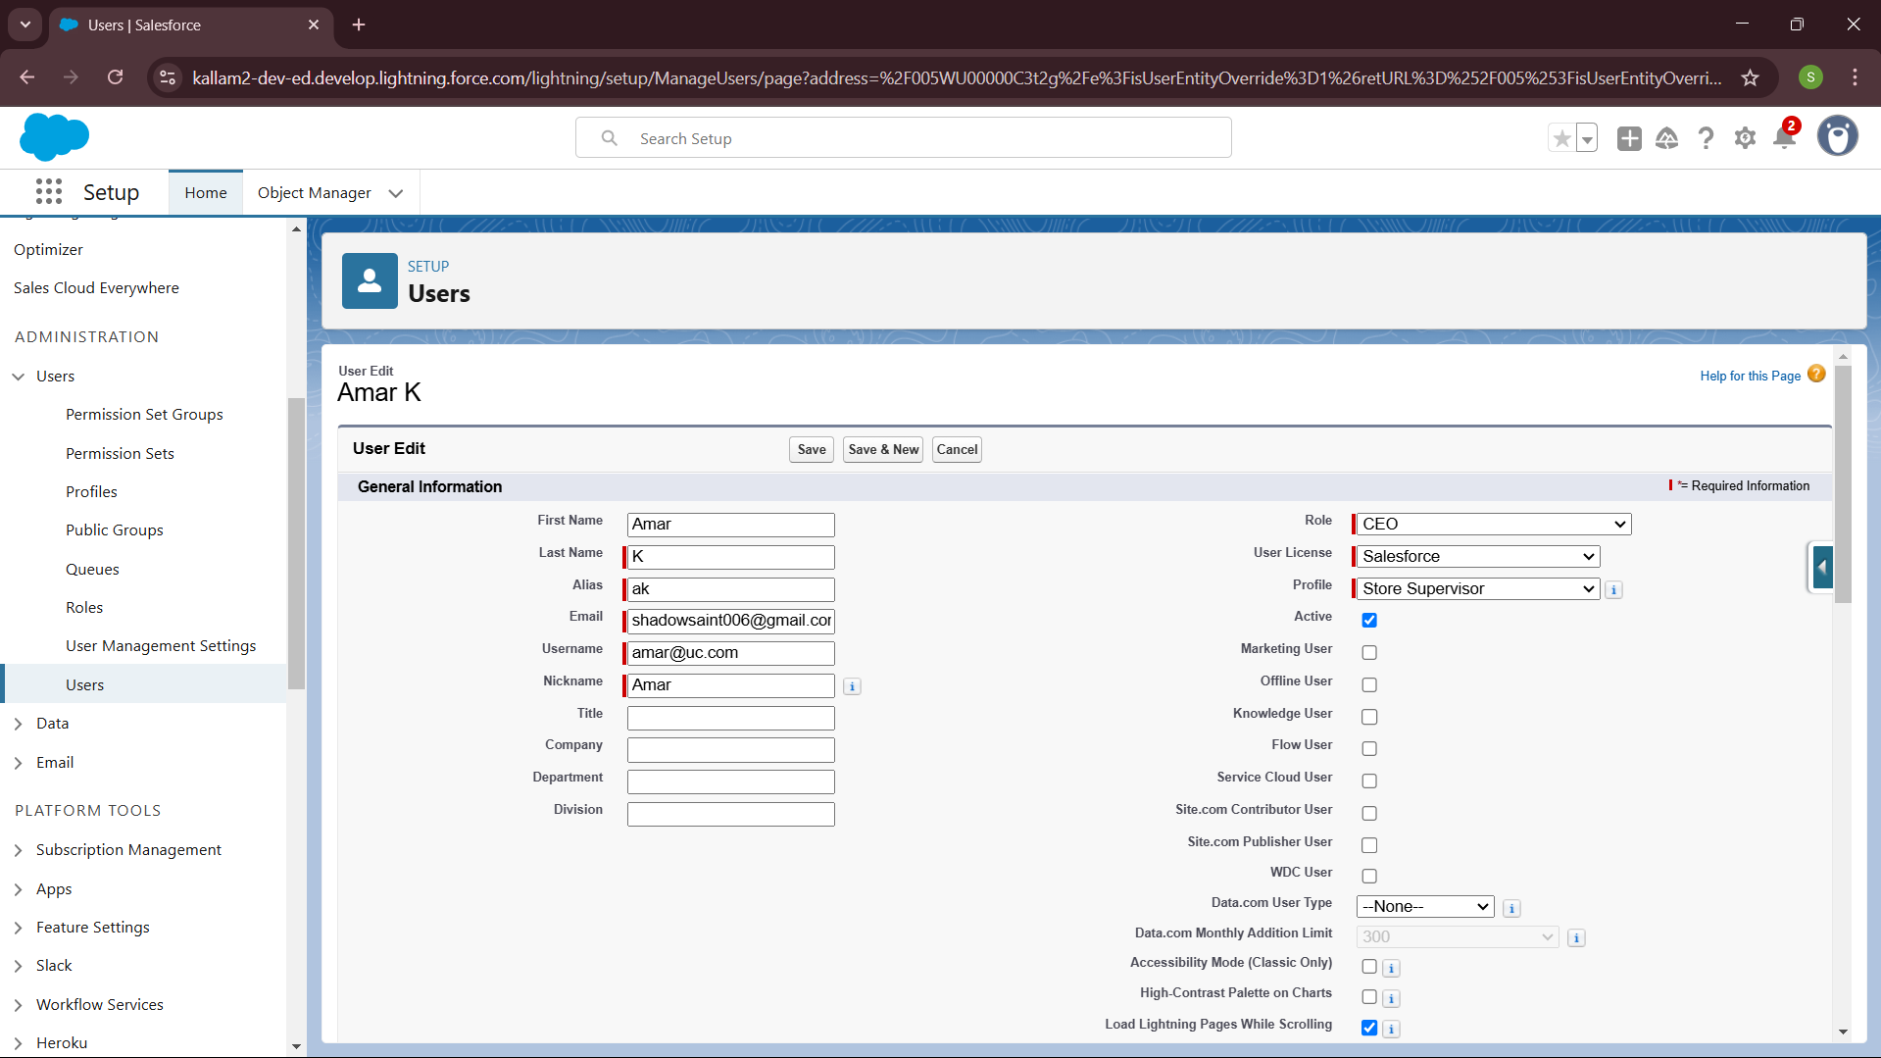

**II. Second User Creation:**

From Setup, in the Quick Find box, enter Users, and then select Users.

* Click New User.
* Enter the user’s name John Teddy and (Your) email address and a unique username in the form of an email address. By default, the username is the same as the email address.
* Select a Role(Billing Operator)
* Select a User Licence As Salesforce Platform.
* Select a profile as Billing Operator.
* Check Generate new password and notify the user immediately to have the user’s login name and a temporary password emailed to your email.

Fill in the fields (first name, last name, alias, email id, username, nick name, role, user licence, profiles) --> save.

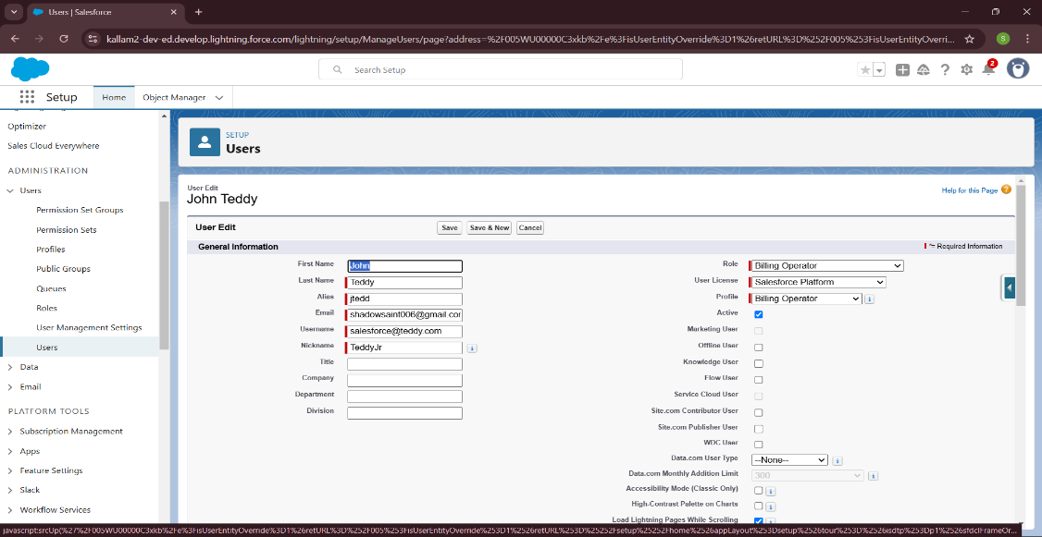

**8. User Adoption (Creating, Viewing and Deleting of Records):**

**I. Creating Customer Records:**

* Click on App Launcher on left side of screen.
* Search Urban Color & click on it.
* Click on Our Customer tab.
* Click new button
* Fill all Our Customer record details.
* Click on Save Button

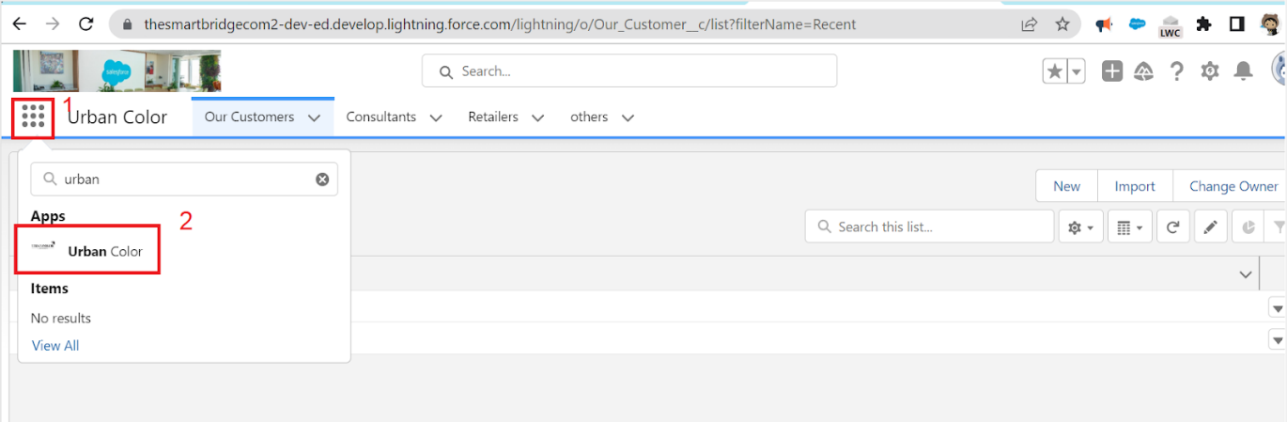

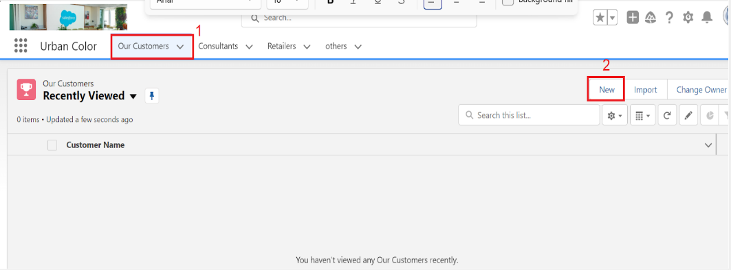

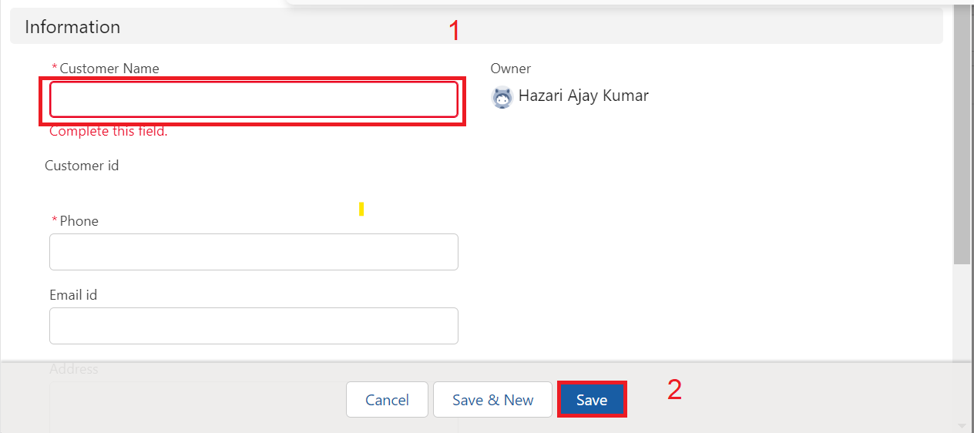

**II. Viewing Customer Records:**

View Record (Our Customer):

* Click on App Launcher on the left side of the screen.
* Search Urban Color & click on it.
* Click on Our Customer Tab.
* 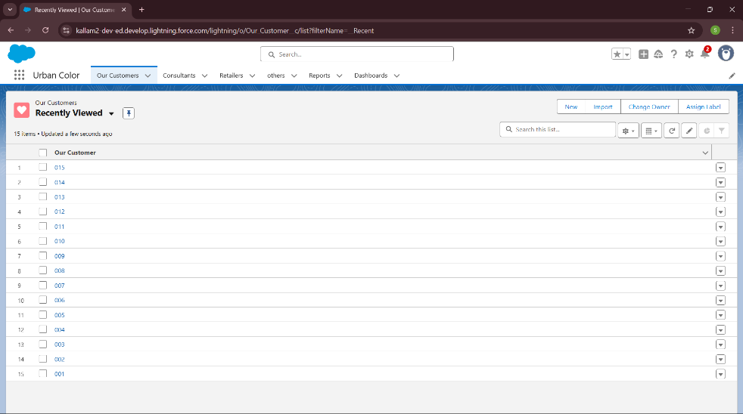Click on any record name. you can see the details of the Our Customer.

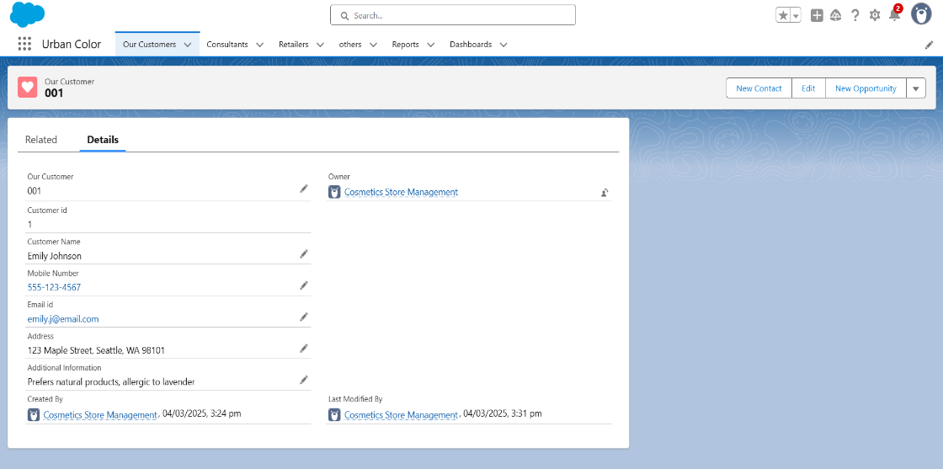

**III. Deleting Records:**

Delete Record (Our Customer):

* Click on App Launcher on the left side of the screen.
* Search Urban Color & click on it.
* Click on Our Customer Tab.
* Click on Arrow at right hand side on that Particular record.
* 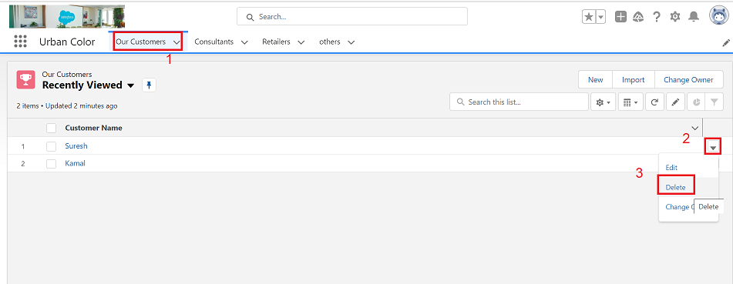Click delete and delete again.

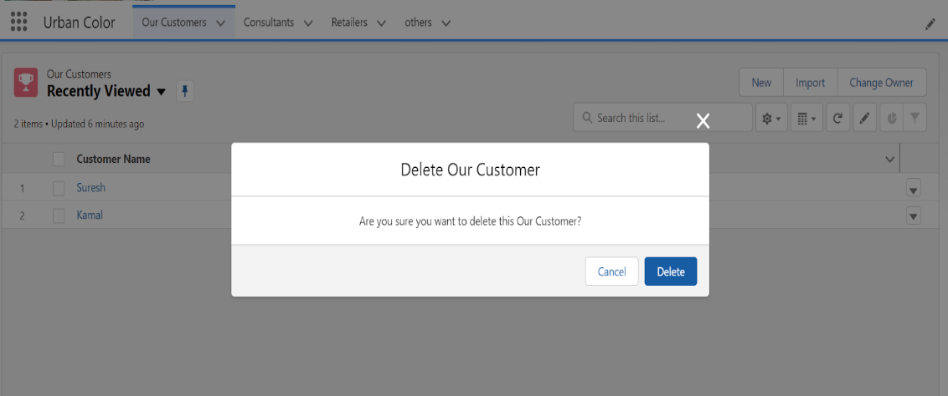

**9. Import Data:**

* From Setup, click the Home tab.
* In the Quick Find box, enter Data Import and select Data Import Wizard
* 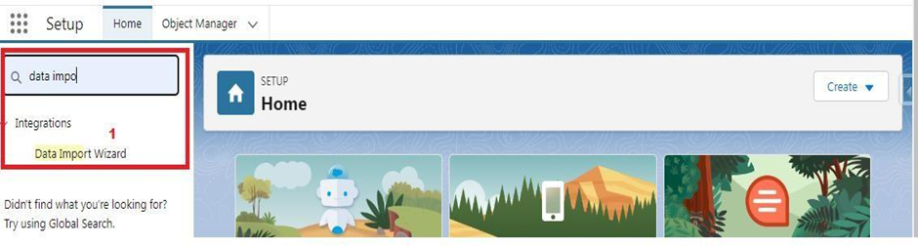Click Launch Wizard!

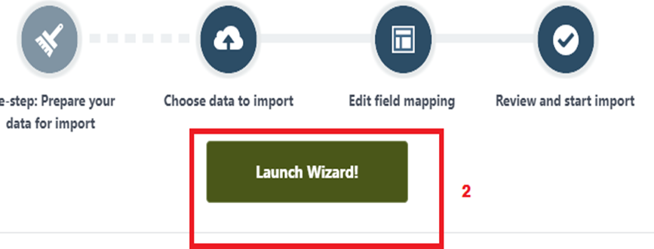

* 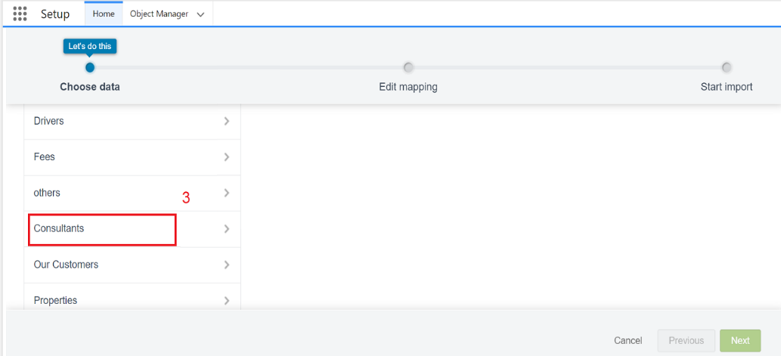Click the Custom Objects tab and select the Consultant object.
* 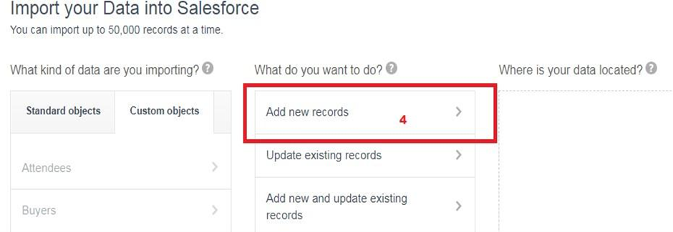Select Add new records.
* 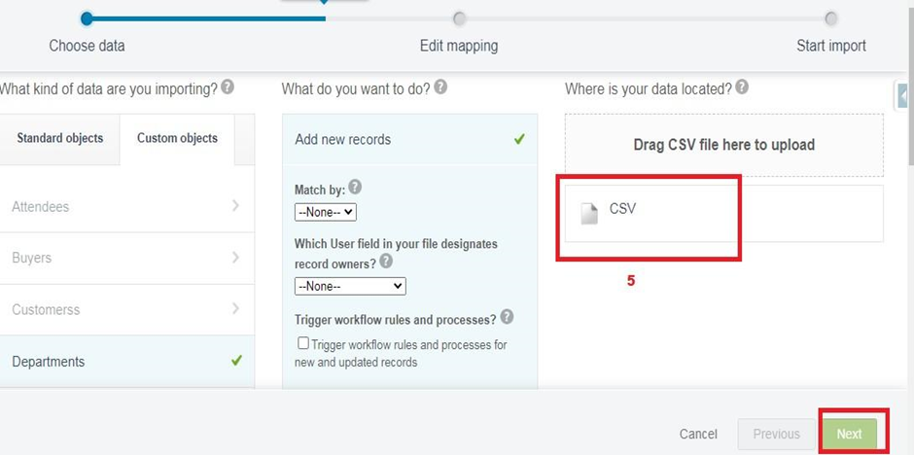Click CSV and choose file Consultant_CSV which we made earlier. Click Next.
* 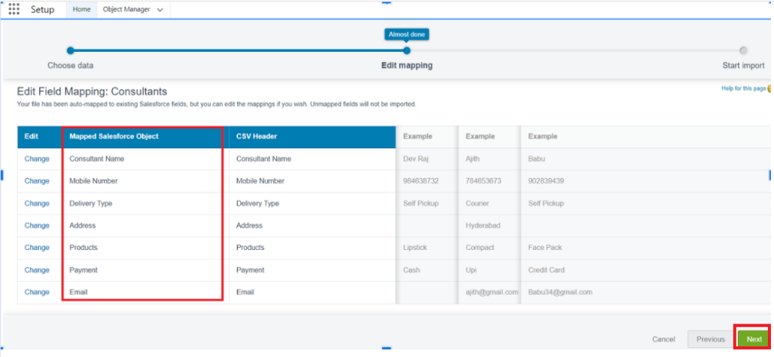Since the field names in the CSV file (CSV Header) are the same as the field names in your object (Mapped Salesforce Object), the fields are automatically mapped. Click Next.
* 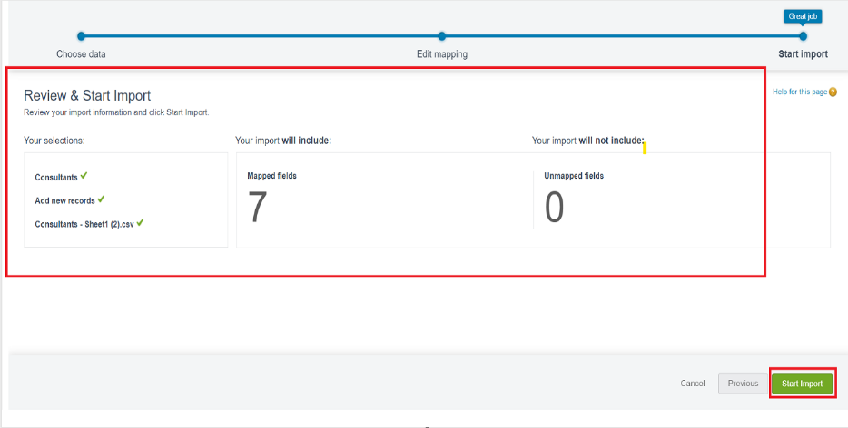The next screen gives you a summary of your data import. Click Start Import.
* 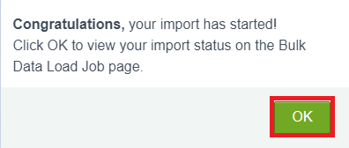Click OK on the popup.
* Scroll down the page and verify that your data has been imported under batches.  
  
* Make sure you have 0 records under the records failed column.  
  **Note** - Do Field mapping carefully.

**10. Reports:**

**I. Creating Reports:**

* Click App Launcher
* Select Urban Color App
* Click reports tab
* Click New Report.
* Click the report type as Consultants Click Start report.
* Customize your report, in Columns select – Consultant Name, Delivery type, Products, Payment.
* Click on the drop-down option on the payment column and select Bucket this column.
* Bucket Name as Payment type
* Click on Add Bucket and name it as Net Banking
* Click on Add Bucket and name it as Cash
* Now Click on All Values and select Credit card, Debit card, UPI and Move to Net Banking.
* Now Click on All Values again and select Cash and Move to Cash.
* Click on Apply.

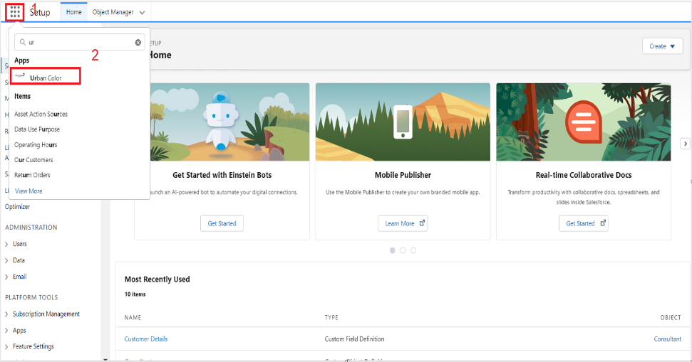

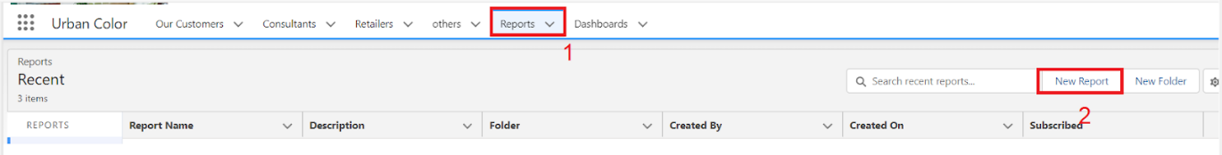

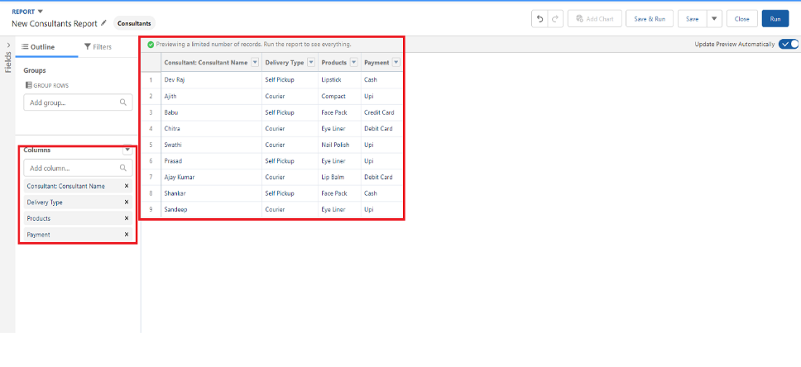

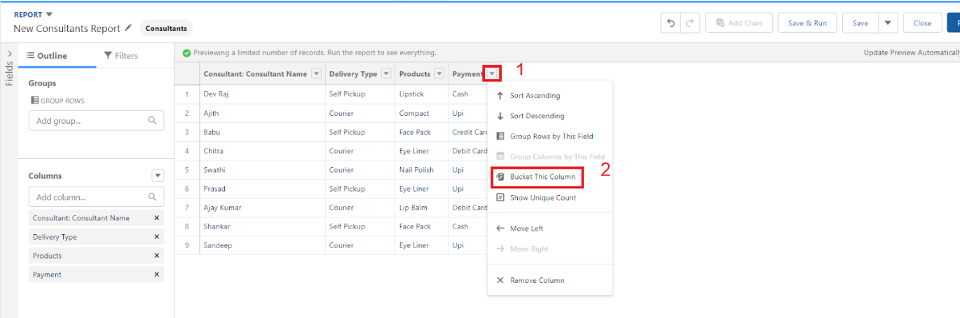

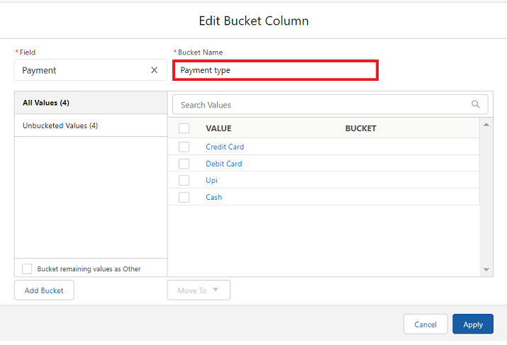

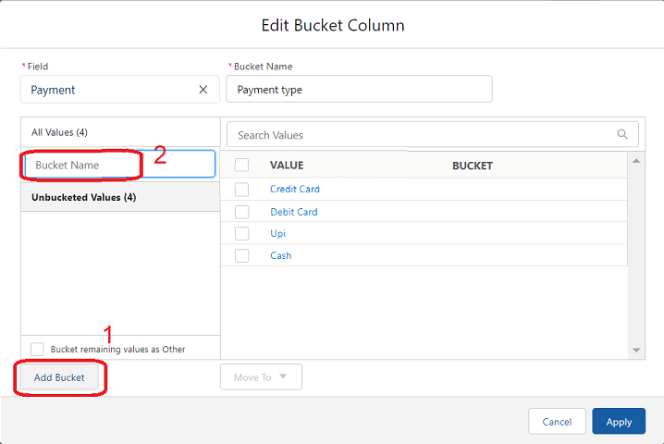

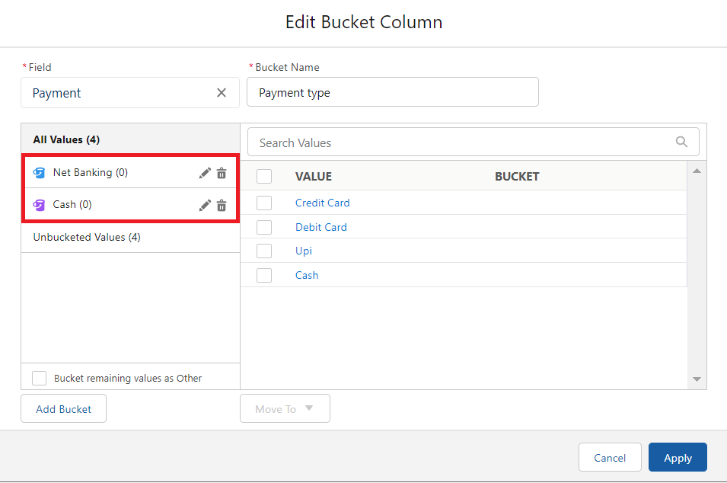

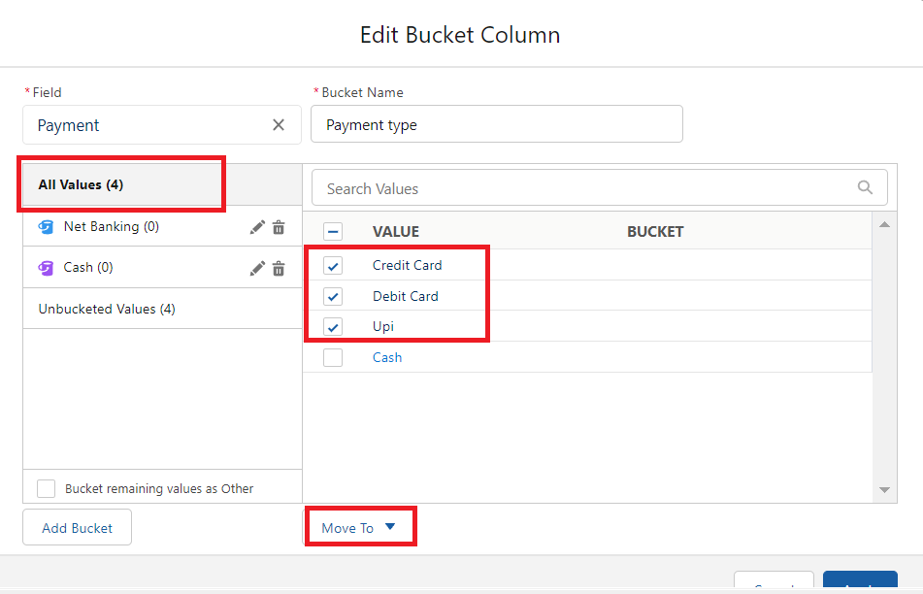

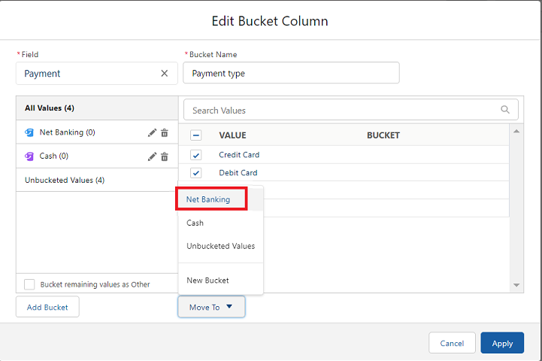

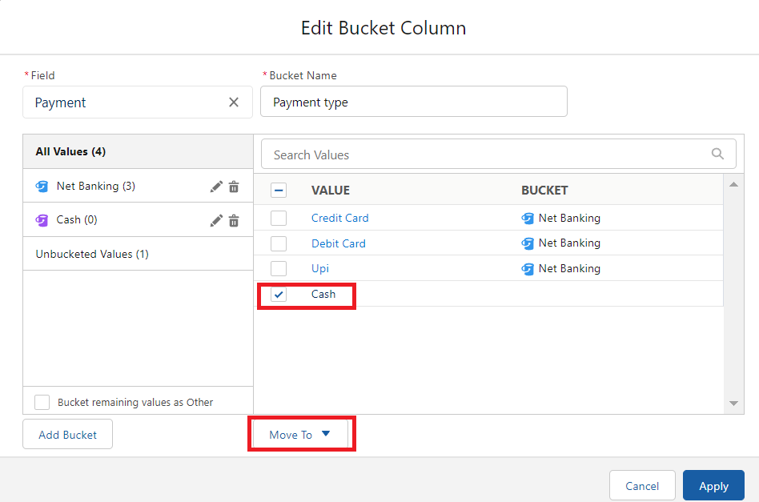

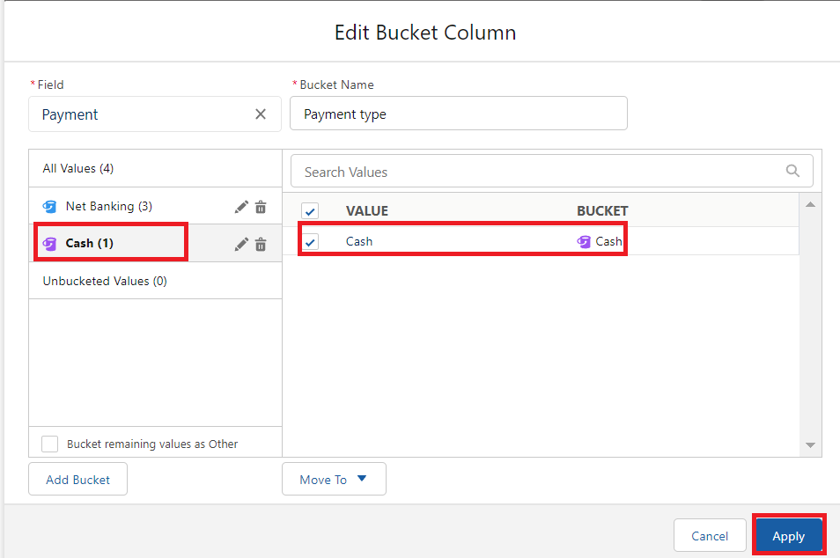

* In Group Rows Add Payment Type Bucket Field.
* 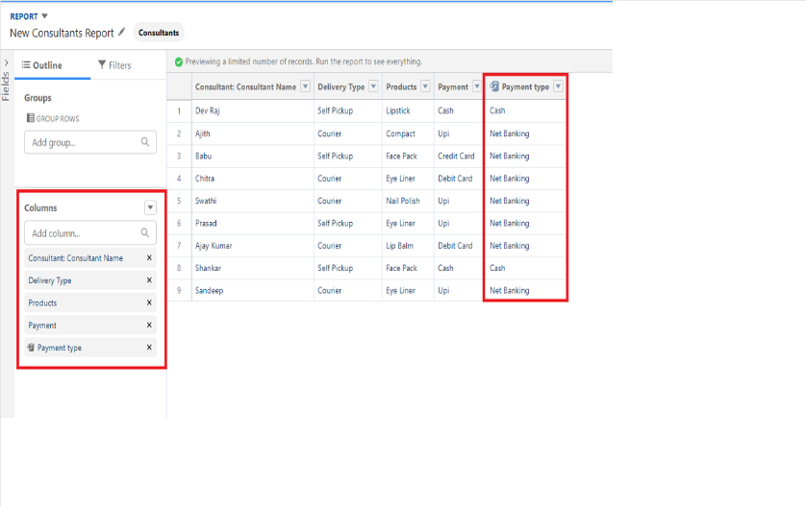Click refresh.
* Click Save and Run.
* Give report name –

Consultant report.

* Click Save.

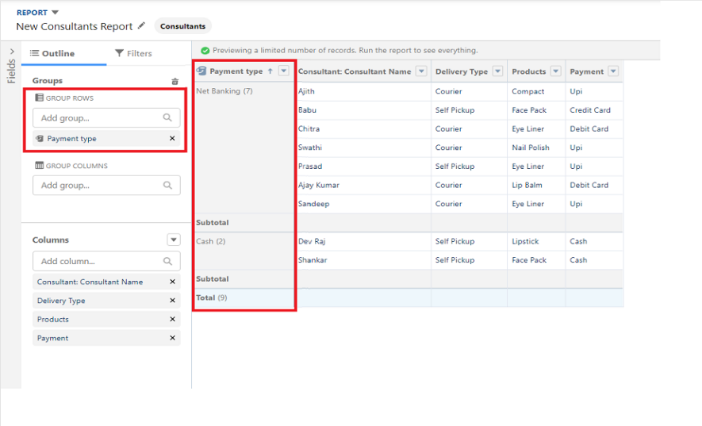

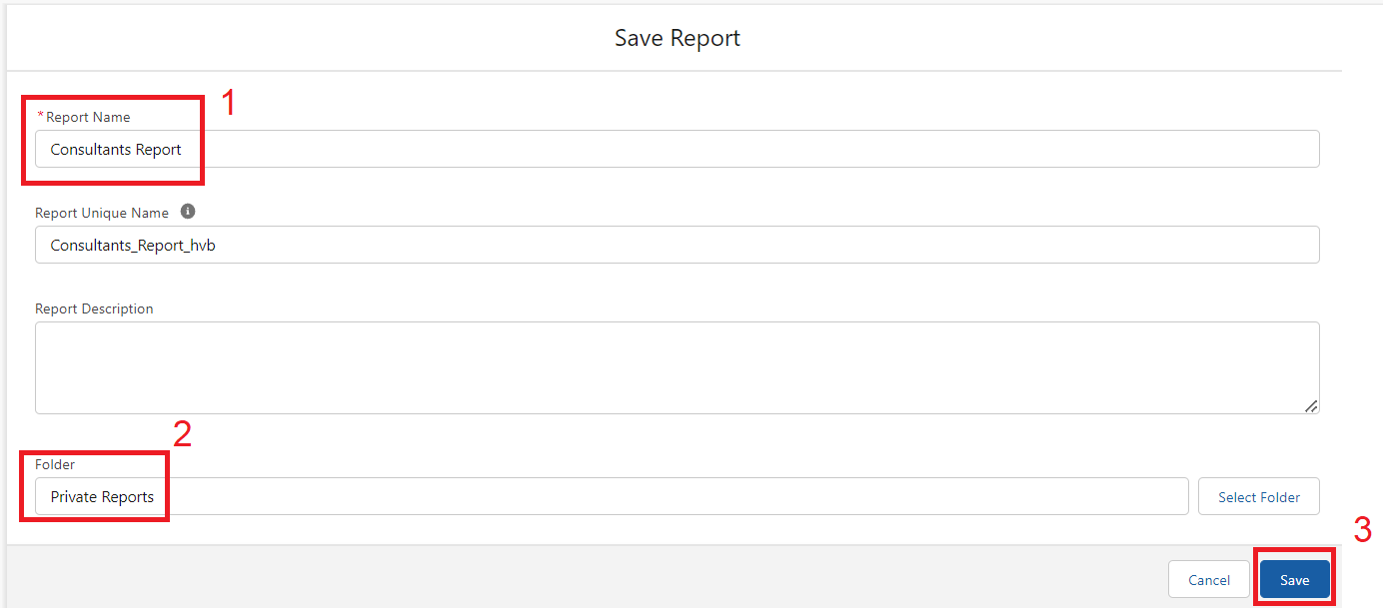

**II. Viewing Reports:**

Click on App Launcher on the left side of the screen.

* Search Urban Color App & click on it.
* Click on Reports Tab.
* Click on Urban Color Report and see records.

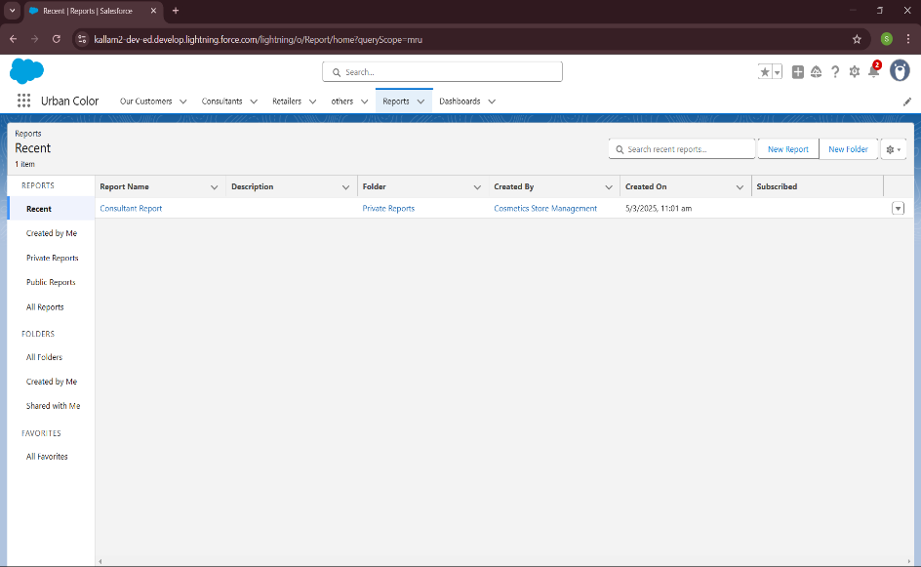

**11. Dashboards:**

**I. Creating Dashboards:**

* Click on the Dashboards tab from the Urban Color application.
* Click on the new dashboard.
* Give name- Consultant Dashboard
* Click create
* Give your dashboard a name and click on +component
* Select the Consultants Report which you created.
* For the data visualization select any of the chart, table etc. as per your choice/requirement.
* 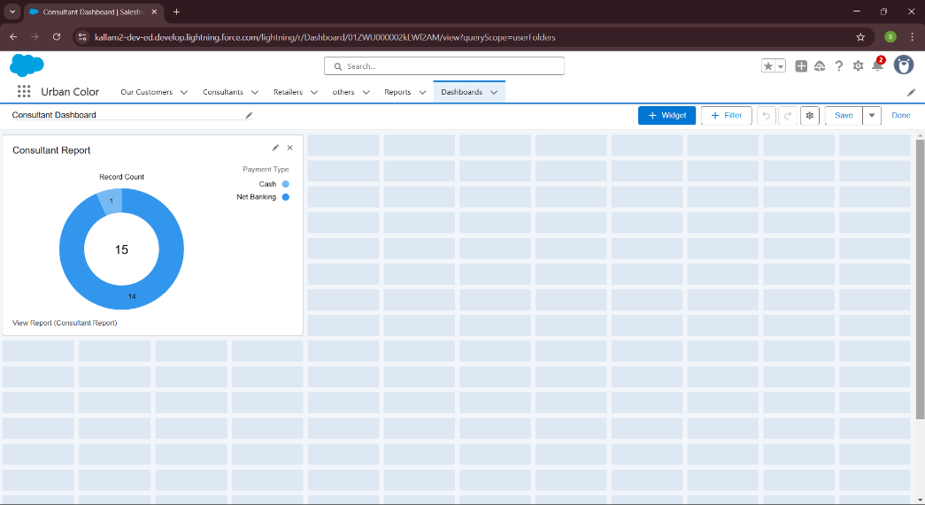Click add.
* Click save.

**II. Viewing Dashboards:**

* Click on App Launcher on the left side of the screen.
* Search Candidate Internal Result Card & click on it.
* Click on Dashboard Tab.
* Click on Candidate Internal Result Card see graph view of records.

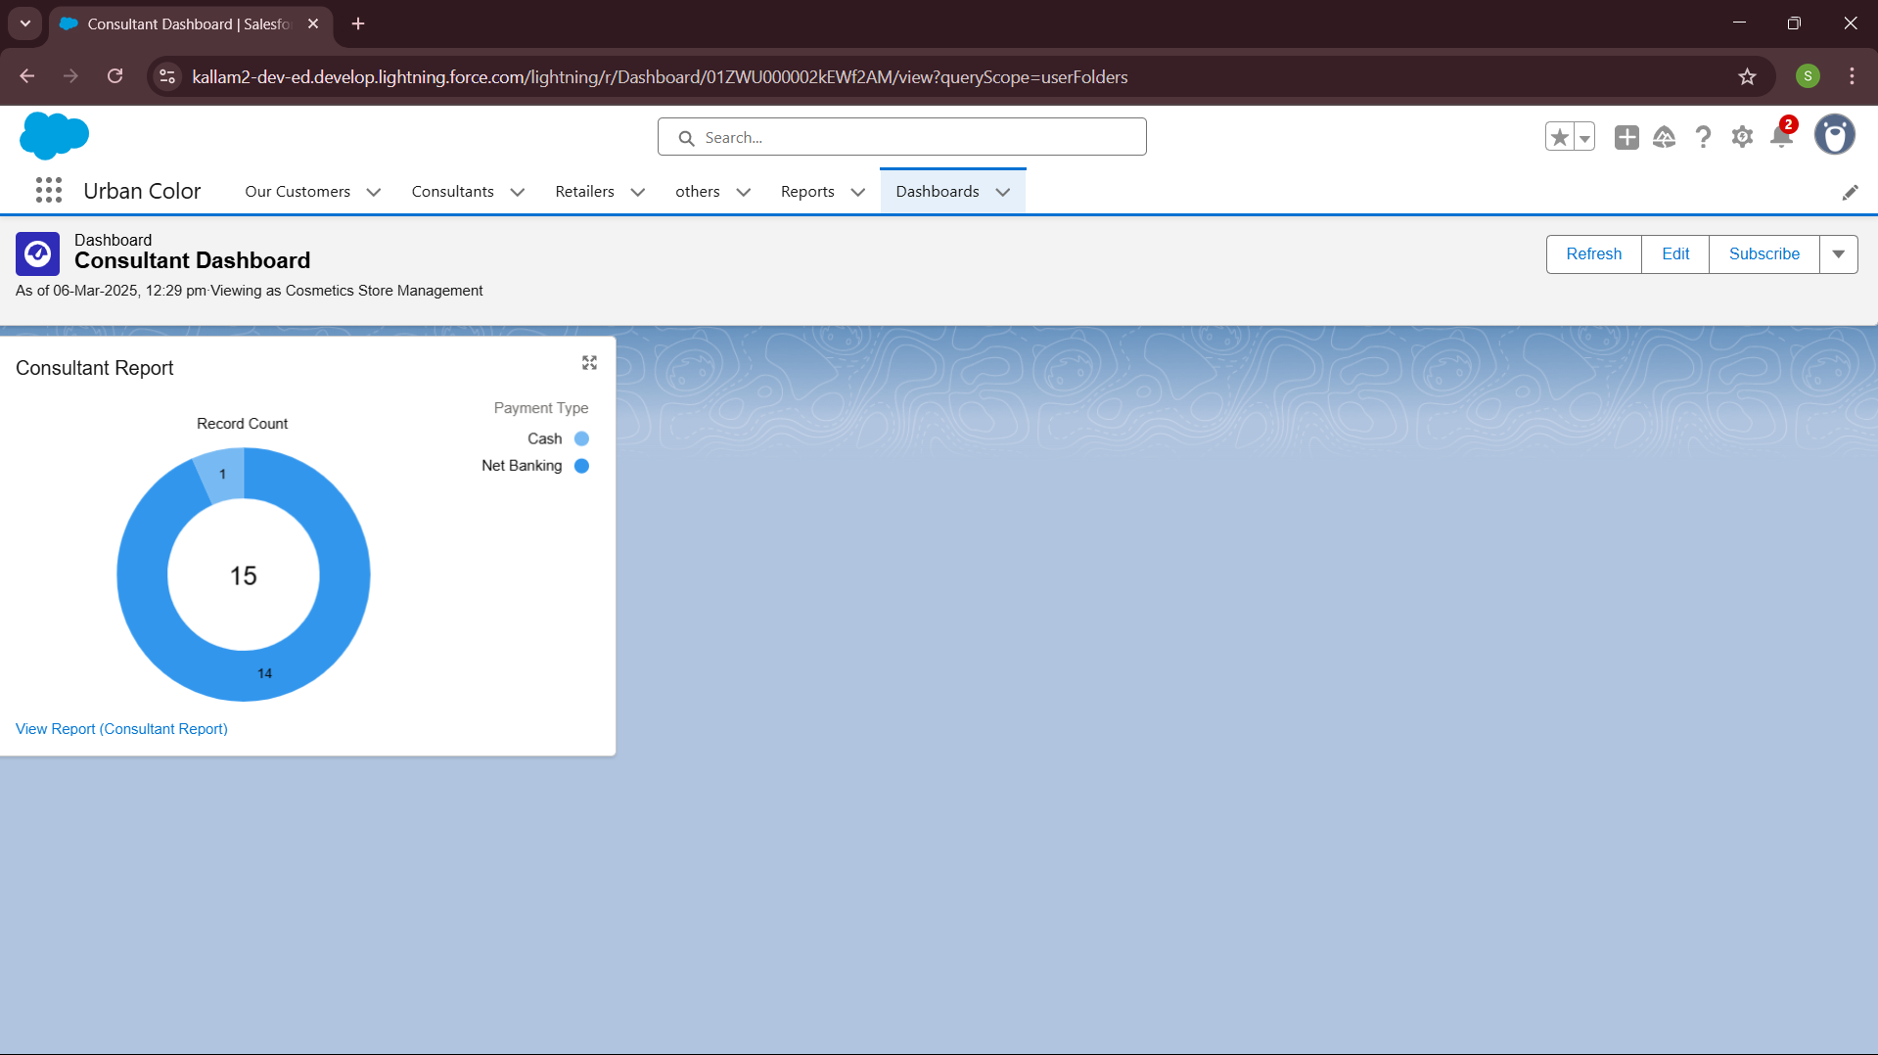

# 

# **Project Conclusion**

The Cosmetics Store CRM project delivers a comprehensive solution tailored to the unique needs of beauty retailers, integrating customer relationship management with inventory control and marketing automation. Through methodical development using Salesforce's robust platform capabilities, the system successfully addresses key operational challenges identified during stakeholder consultations. The implementation provides detailed customer insights, streamlines inventory management, and enables data-driven marketing decisions. With successful deployment across multiple store locations, the CRM now serves as a central operational hub, enhancing customer satisfaction while driving increased sales performance and operational efficiency. The transformative impact of this solution positions the business for sustainable growth in the competitive cosmetics retail market.